

S. P. Mandali’s

**RAMNARAIN RUIA AUTONOMOUS COLLEGE**

**MATUNGA, MUMBAI - 400019**

**DEPARTMENT OF COMPUTER SCIENCE & IT**

**FIELD PROJECT REPORT**

**Course Code:-** RPSCSP .O605

**Restaurant Management System**

**Guide Name**

**Mrs. Edith June**

**Submitted By**

**Janhavi Sharad Shedge**

**Seat No – 287**

**M.Sc Sem II Computer Science**

**2023-2024**

**ACKNOWLEDGEMENT**

I have a great pleasure in representing this project report entitled "RESTAURANT MANAGEMENT WEBSITE" and I grab this opportunity to convey my immense regards towards all the distinguished people who have their valuable contribution in the hour of need.

I like to extend my gratitude to our beloved Principal Dr. Anushree Lokur for her timely and prestigious guidance.

I take this opportunity to thank Ms. Megha Swant, Coordinator of the Department and all the faculty members of the Department of Computer Science of Ramnarain Ruia College, for giving me an opportunity to complete this project and the most needed guidance throughout the duration of the programme.

I am extremely grateful to my project guide Edith Juni for their valuable guidance and necessary support during each phase of the project. She was the source of continuous encouragement as cach milestone was crossed.

A special thanks to the Ramnarain Ruia College for having prescribed this project work to me as a part of the academic requirement in the First year of Masters of Computer Science.

Finally I also owe to my fellow friends who have been a constant source of help to solve the problems that cropped up during the project development process.

Janhavi Sharad Shedge

**1}Title:**

**RESTAURANT MANAGEMENT WEBSITE**

**TABLE OF CONTENTS**

|  |  |  |  |
| --- | --- | --- | --- |
| **Sr. No.** |  | **Contents** | **Page No.** |
| 1. |  | Title | 3 |
| 2. |  | Problem definition | 5 |
| 3. |  | Introduction | 6-7 |
| 4. |  | System Analysis | 8-12 |
| 5. |  | System Design | 13-23 |
| 6. |  | Implementation Design | 24-88 |
| 7. |  | Output and Reports Testing | 89-90 |
| 8. |  | Conclusion and Recommendations | 91 |
| 9. |  | Further Scope | 92 |
| 10. |  | Bibliography and References | 93 |

**2}PROBLEM DEFINATION**

Shambhavi Restaurant's operational inefficiencies stem from its lack of a website and outdated manual processes. The absence of an online platform deprives the restaurant of essential visibility, hindering its ability to showcase its offerings and attract potential customers. Manual order-taking procedures not only increase the likelihood of errors and delays but also diminish overall customer satisfaction. Additionally, the restaurant's inability to engage with customers digitally deprives it of valuable feedback and opportunities for service improvement. Managing orders and supplies manually further exacerbates inefficiencies, leading to increased costs and decreased operational effectiveness. Moreover, the lack of accessible online information such as menus and operating hours reduces the likelihood of potential customers visiting the restaurant. Overall, Shambhavi Restaurant's failure to embrace digital solutions and streamline its processes poses significant challenges to its competitiveness and long-term success in the modern restaurant landscape.

**3}INTRODUCTION**

In today's digital era, the integration of technology into restaurant management systems has become imperative for staying competitive and meeting customer expectations. Shambhavi Restaurant recognizes the need to modernize its operations to enhance efficiency, customer satisfaction, and overall performance.

**3.1}Motivation:**

The motivation behind this project lies in addressing the operational challenges faced by Shambhavi Restaurant due to its reliance on manual processes and the absence of a digital presence. By leveraging technology, the restaurant aims to streamline its operations, improve customer experience, and ultimately increase revenue.

**3.2}Problem Statement:**

Shambhavi Restaurant faces inefficiencies in order management, communication with customers, and accessibility of information due to the lack of a website and outdated manual processes. These challenges hinder the restaurant's growth potential and competitiveness in the market.

**3.3}Purpose/Objective and Goals:**

The purpose of this project is to develop a comprehensive website for Shambhavi Restaurant, providing an online platform for showcasing its offerings, facilitating seamless order management, and enhancing customer engagement. The primary objectives include:

* Creating a user-friendly interface for browsing menus, adding items to the cart, and placing orders.
* Implementing an order tracking system to provide customers with real-time updates on their orders.
* -Establishing a communication channel through which customers can provide feedback and inquiries.
* Enhancing the overall dining experience and increasing customer satisfaction.

**3.4}Literature Survey:**

A review of existing literature in the field of online food delivery systems and restaurant management reveals the importance of digital solutions in improving operational efficiency, customer service, and revenue generation. Studies also highlight the significance of user-friendly interfaces, order tracking mechanisms, and feedback channels in enhancing the overall dining experience.

**3.5}Project Scope and Limitations:**

While the project endeavors to modernize Shambhavi Restaurant's operations, it's vital to recognize its current limitations. These include manual customization of food orders and location updates, alongside the inconvenience of not being able to save payment details or process orders as guests. Future enhancements, like integrating Google Maps for automatic location updates, aim to mitigate these constraints and elevate the overall user experience.

**4}SYSTEM ANALYSIS**

**4.1Existing Systems:**

Currently, Shambhavi Restaurant relies on manual order-taking processes and lacks an online platform for customer interaction and order management.

**4.2}Scope and Limitations of Existing Systems:**

The current manual system results in inefficiencies such as errors in order processing and delays in communication. Additionally, the absence of digital tools limits the restaurant's reach and accessibility.

**4.3}Project Perspective, Features:**

The project aims to develop a comprehensive website for Shambhavi Restaurant, offering features such as online ordering, order tracking, menu browsing, and customer feedback collection.

**4.4}Stakeholders:**

Stakeholders include restaurant management, staff members, customers, and the development team responsible for implementing the website.

**4.5}Data Collection Methods with Proof:**

Data collection methods involve surveys, interviews, and analysis of existing order records to understand customer preferences, operational challenges, and system requirements.

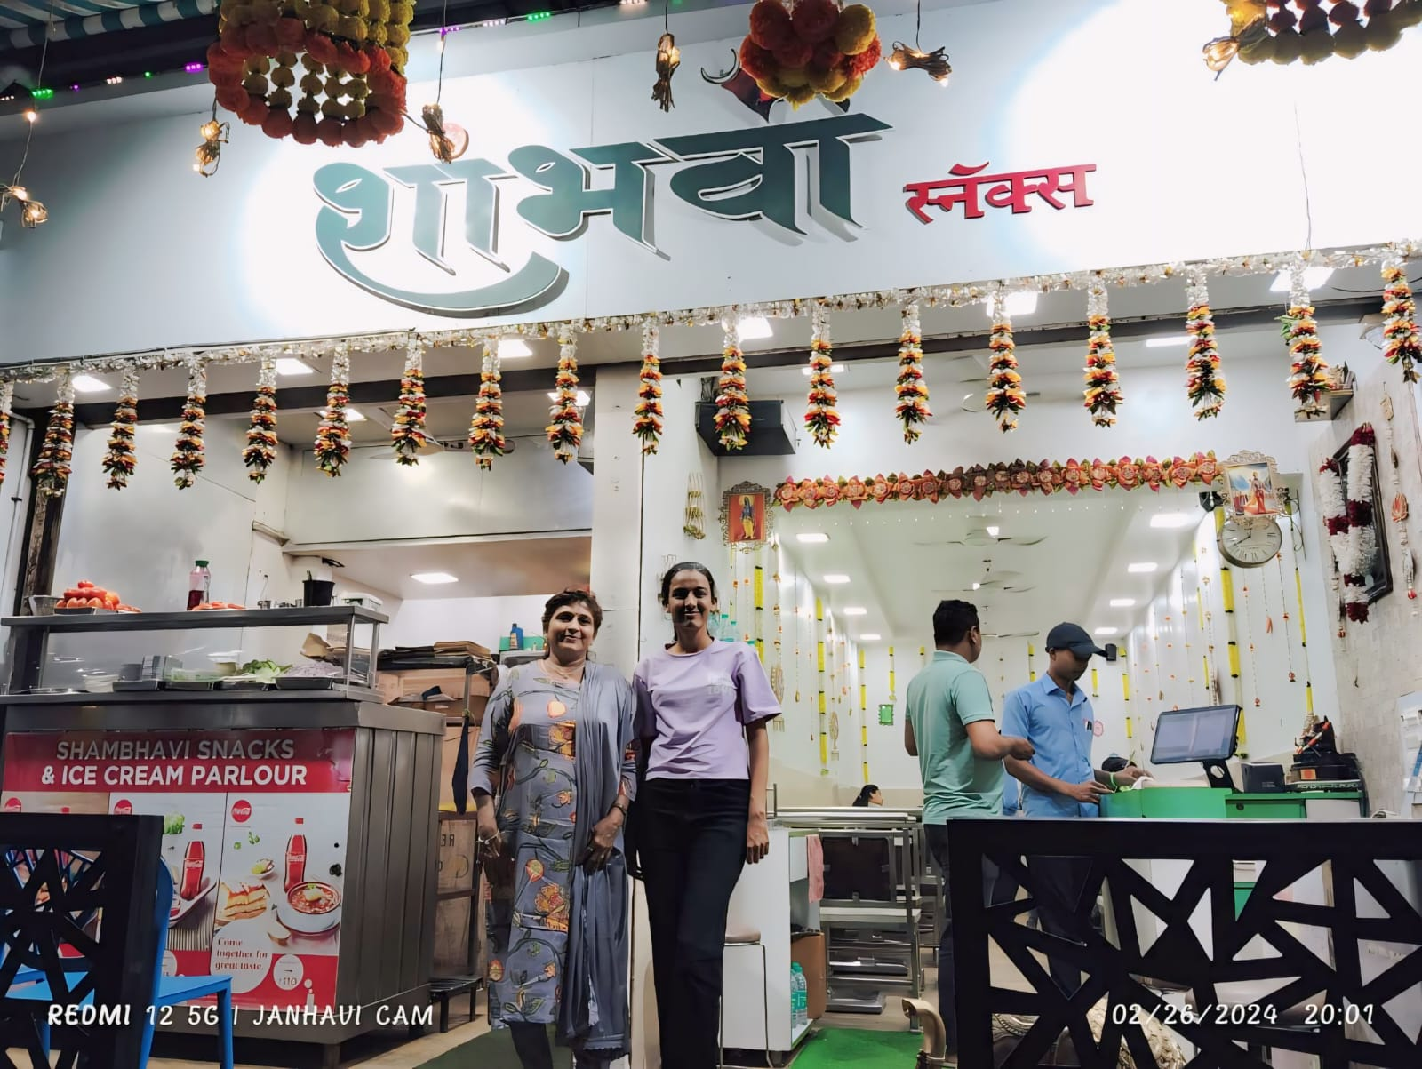

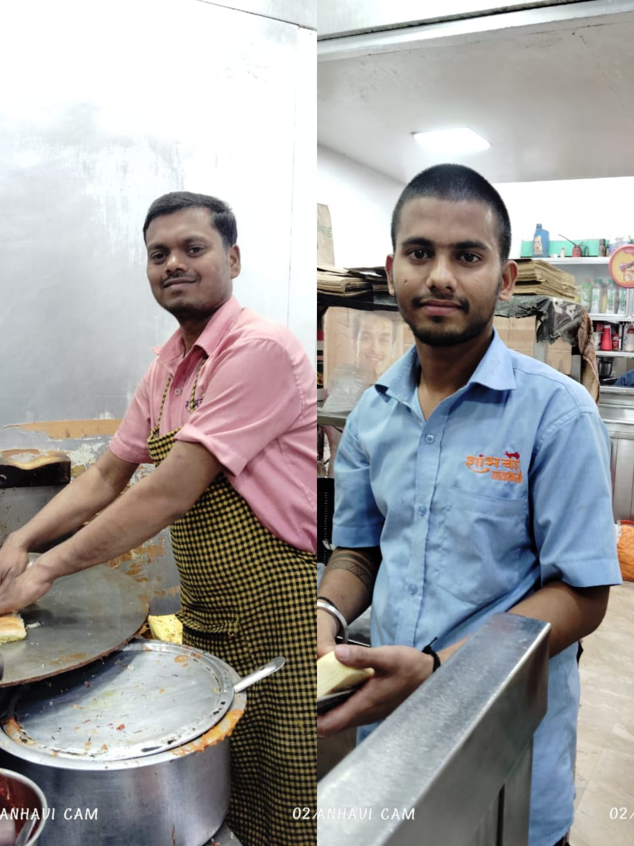

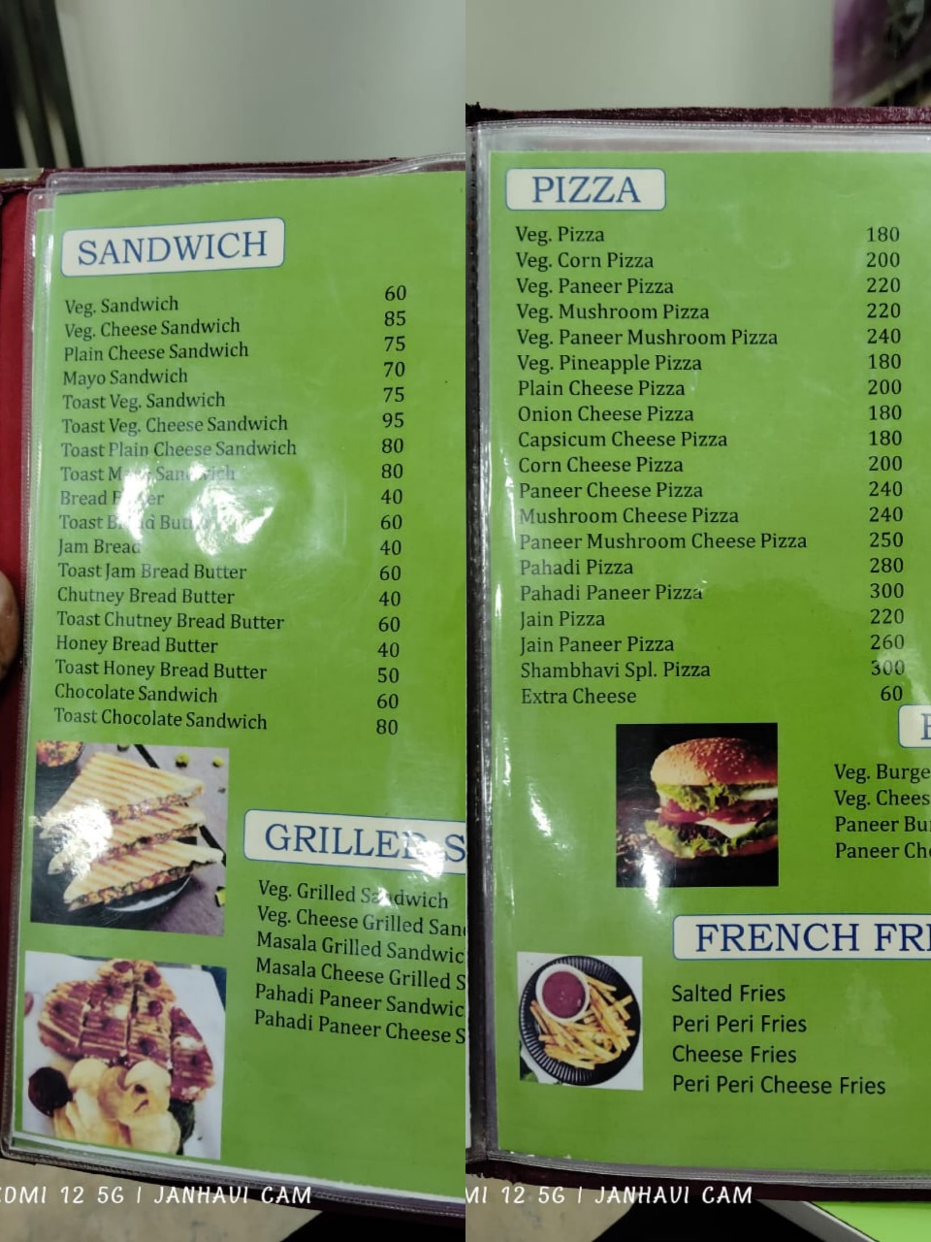

**4.6}Requirement Analysis:**

Functional Requirements

* Customers:

1. Sign Up (only for new customer)

**Input:** “SignUp” option selected.

**Output:** customer prompted to enter the details.

2. Login

**Input:** “Login” option selected.

**Output:** customer prompted to enter the username and password.

3. Select food items

**State:** The customer has logged in and the main menu has been displayed.

**Input:** Items are selected customer feel free to order.

**Output:** System will display selected items.

4. Changes to order

**Input:** “go to cart” option selected.

**Output:** customer can delete or add food item in order.

5. Review the order before submitting

**Input:** “Order Place” option selected.

**State:** Customer name, phone number, location (address) display or enter the all of information.

**Output:** customer prompted to pay the bill.

6. Logout

**Input:** “Logout” option selected.

**Output:** you are successfully logout.

**State:** System display login page.

* Employees:

1. Login (Employee login page)

**Input:** “Login” option selected.

**Output:** Employee prompted to enter the username and password.

2. Modify Menu

**State:** In the system all the items are displayed with their rates.

**Input:** “Change” option selected.

**Output:** Employee can make changings in menu like adding or removing food items which are not available and changings rate of items.

3. Order list

**Input:** “Order list” option selected.

**State:** System display all order details.

**Output**: Employee can make changings like confirm order, prepared order, delivered order, not confirm order.

4. Logout

**Input:** “Logout” option selected.

**Output:** you are successfully logout.

**State:** System display login page.

* Administrators:

➢ Administrators must be able to use Employees all features.

1. Login (admin login page)

**Input:** “Login” option selected.

**Output:** admin prompted to enter the username and password.

2. Logout

**Input:** “Logout” option selected.

**Output:** you are successfully logout.

**State:** System display login page.

**5}SYSTEM DESIGN**

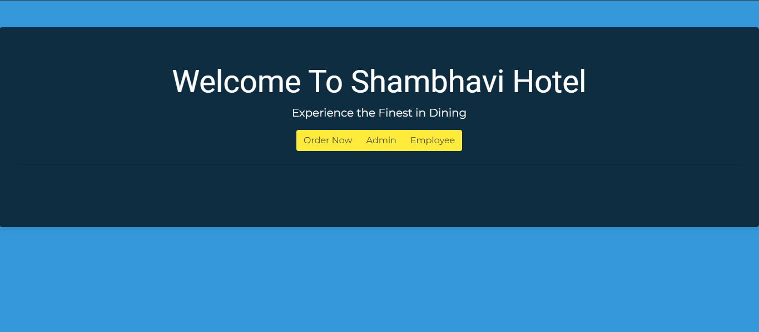

Signup Page:

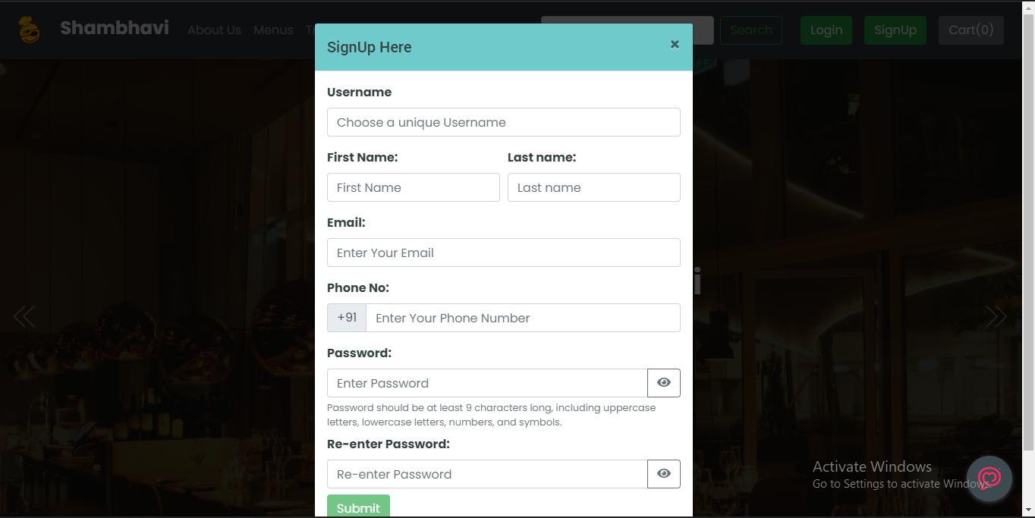

Login Page:

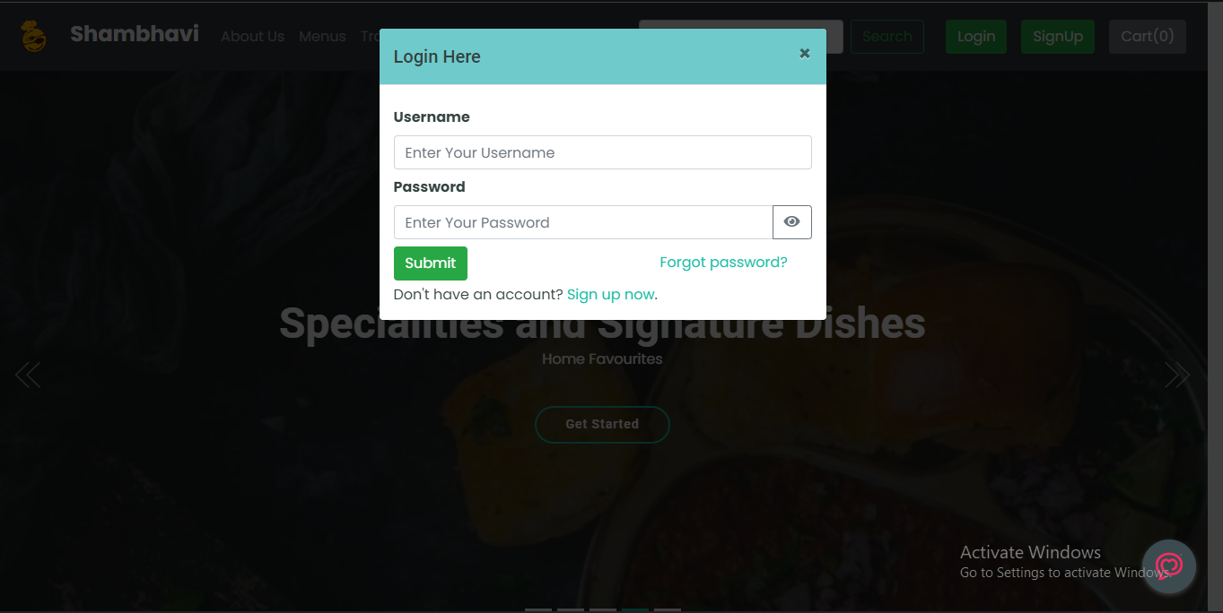

Home Page:

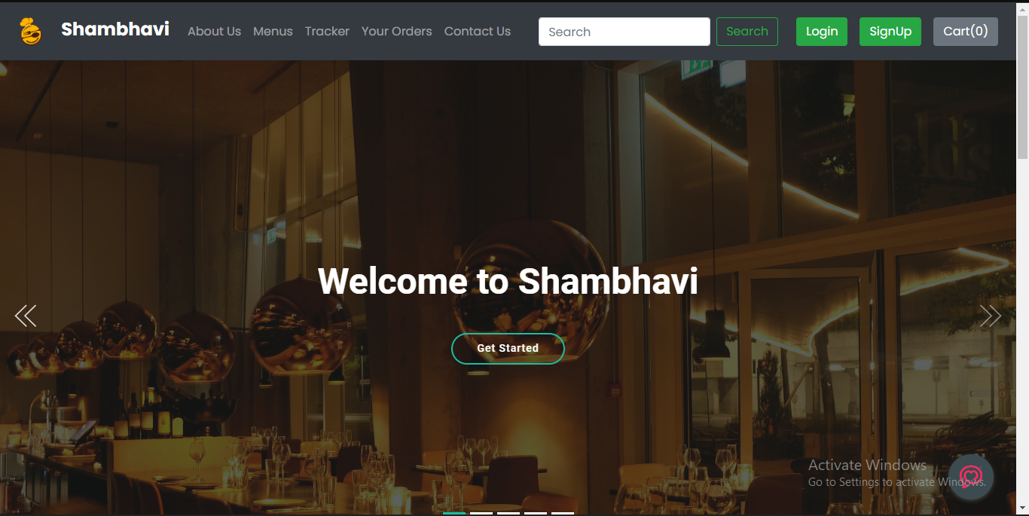

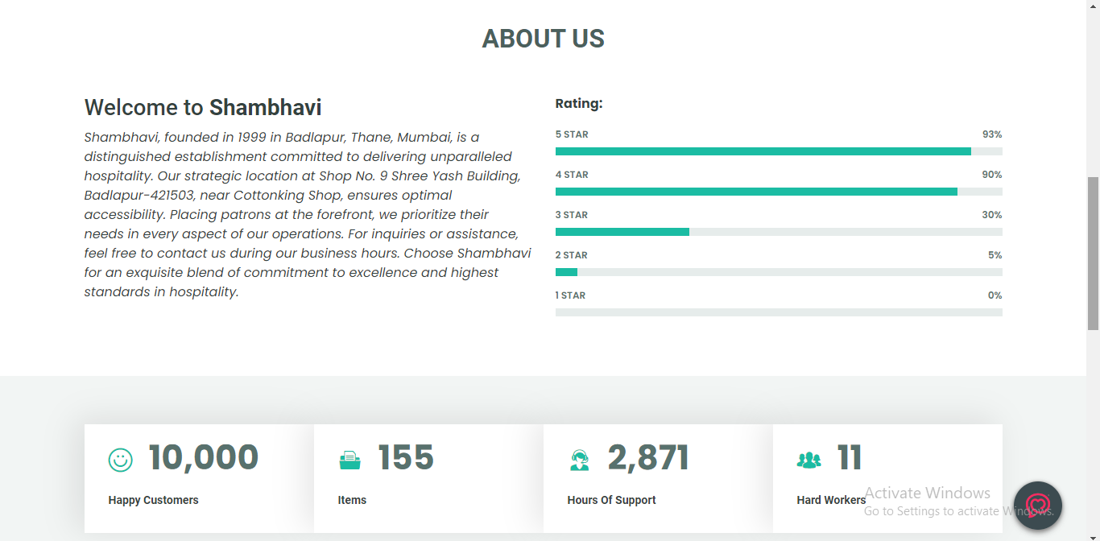

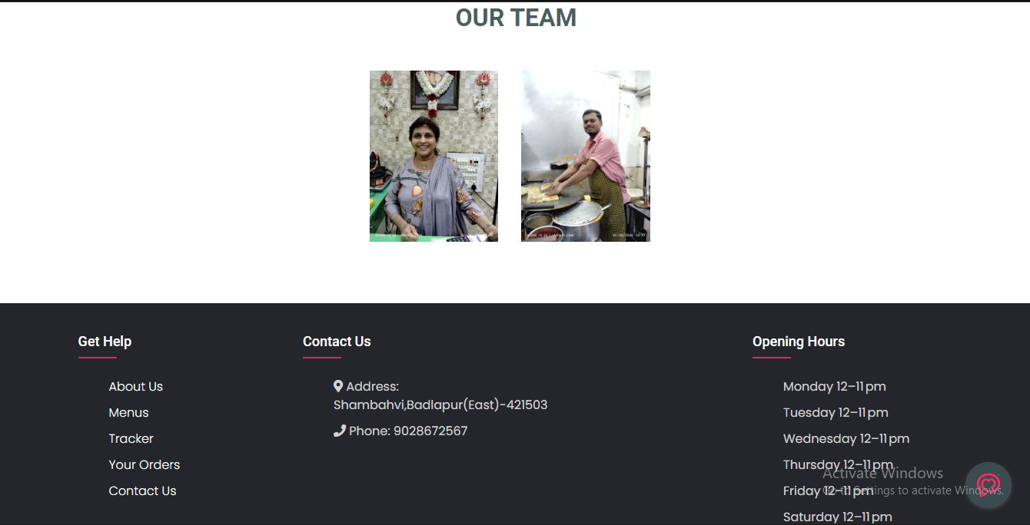

ChatBot:

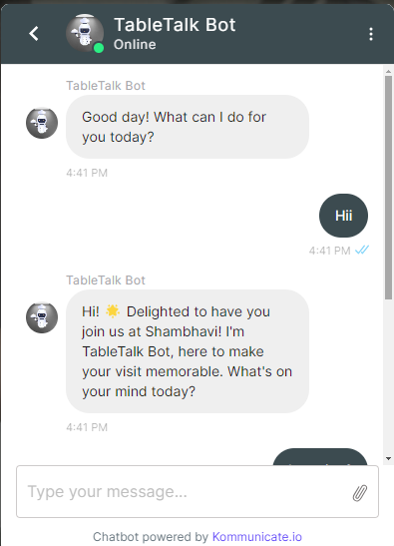

Menus:

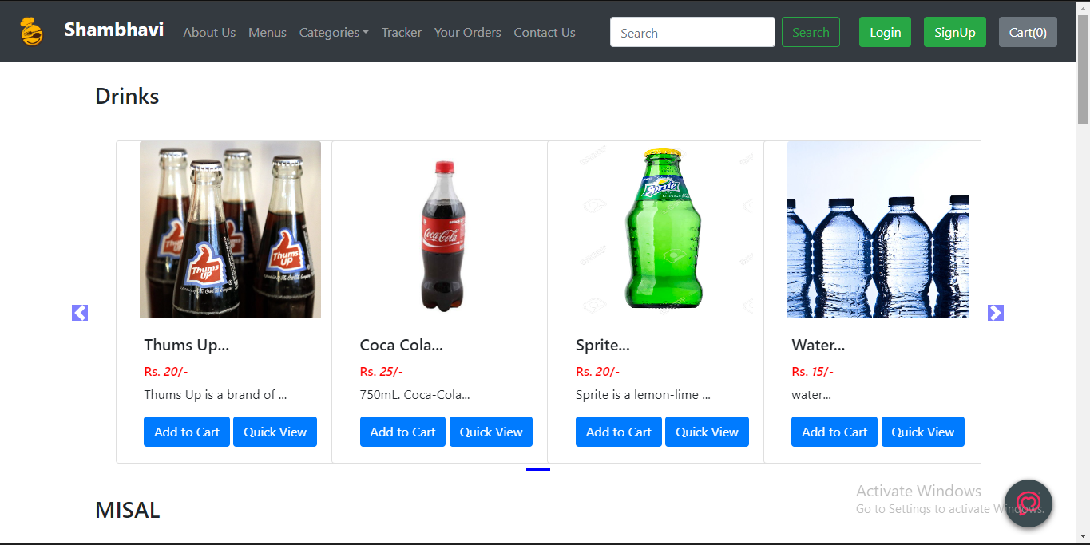

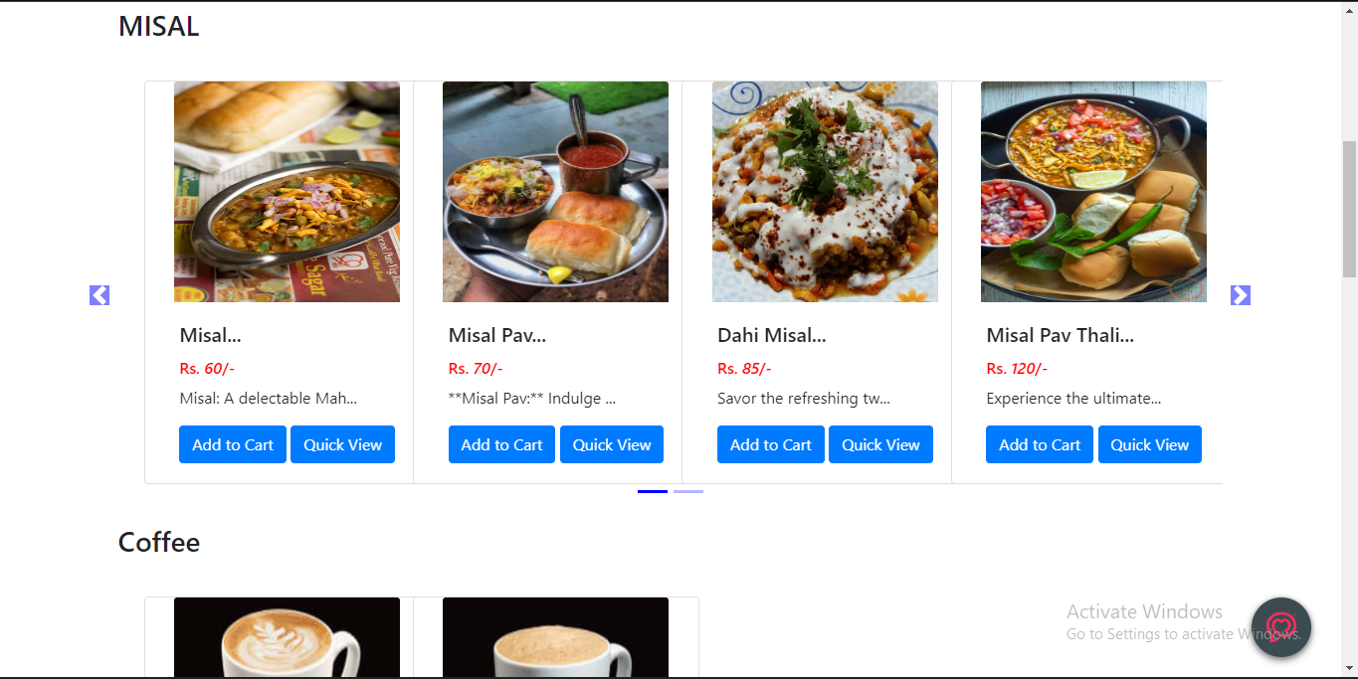

Categories:

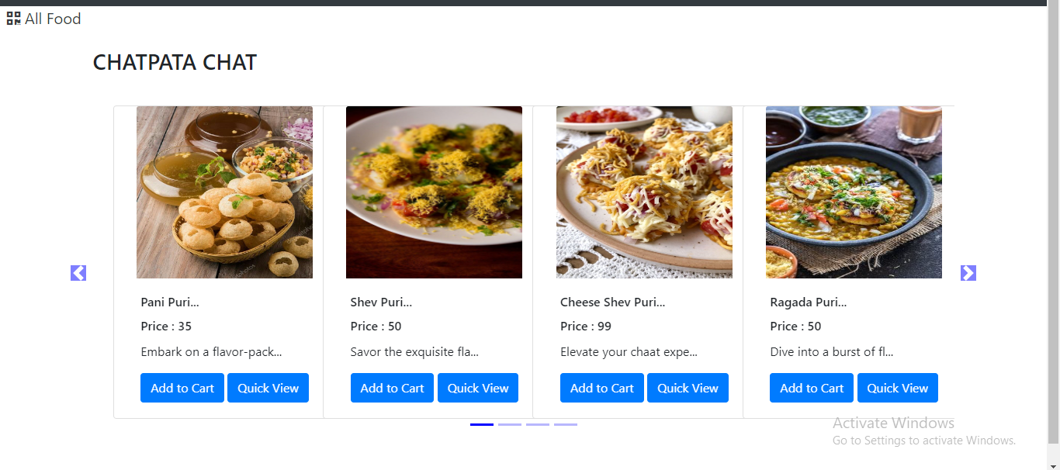

Tracker:

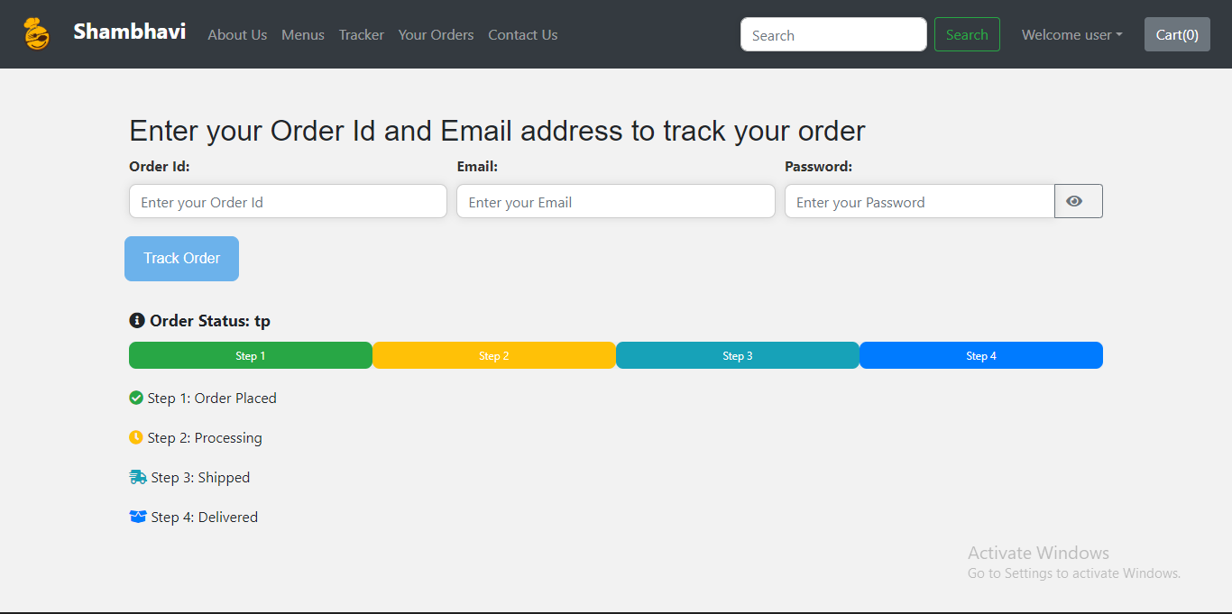

Order Details:

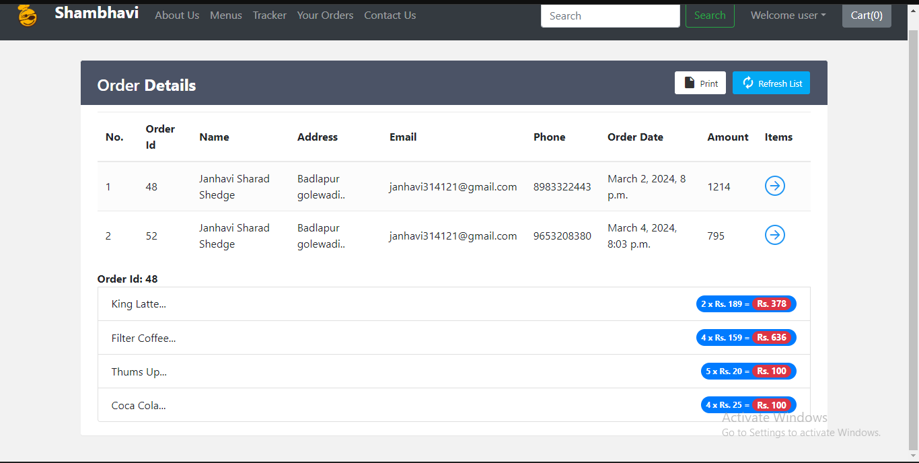

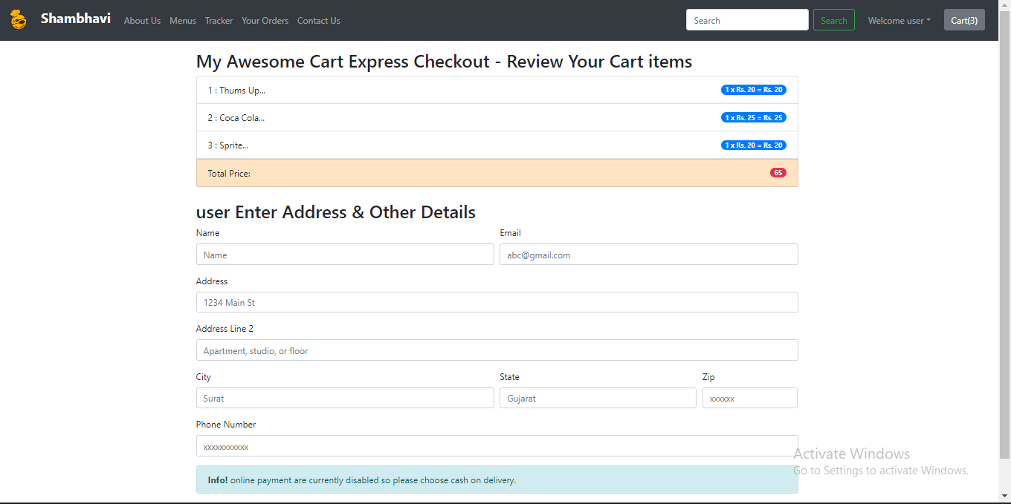

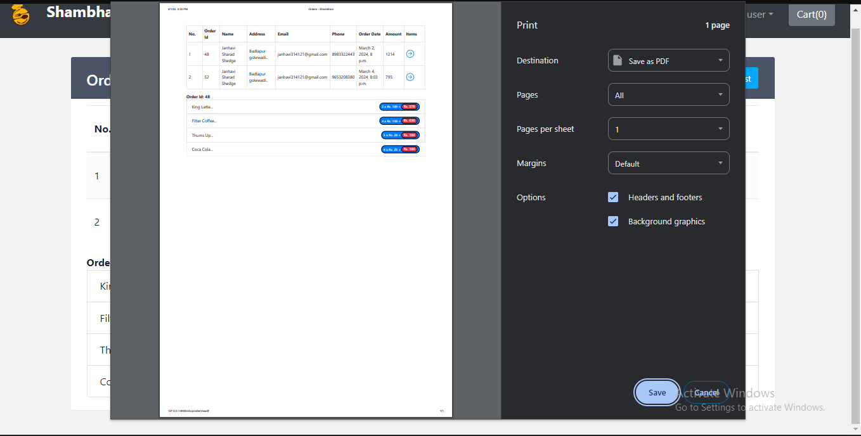

Contact:

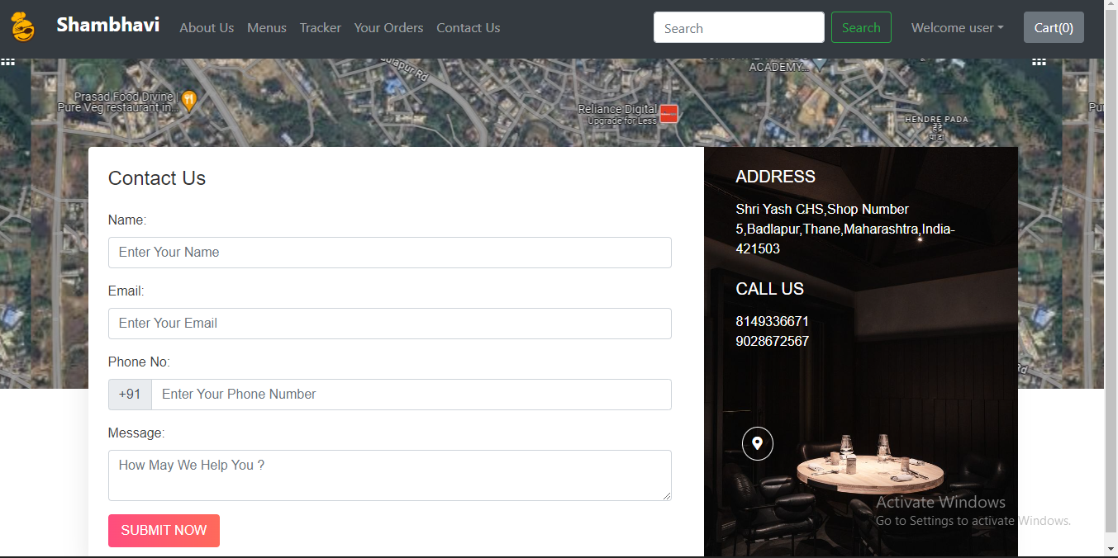

Admin Panel:

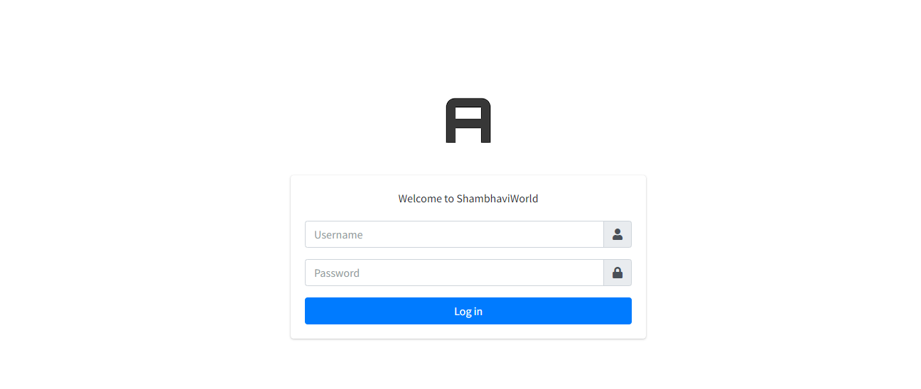

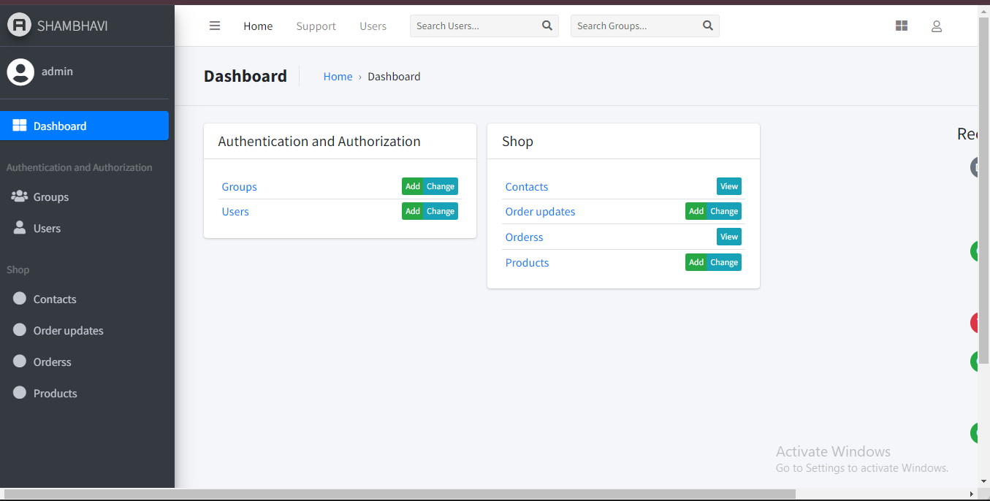

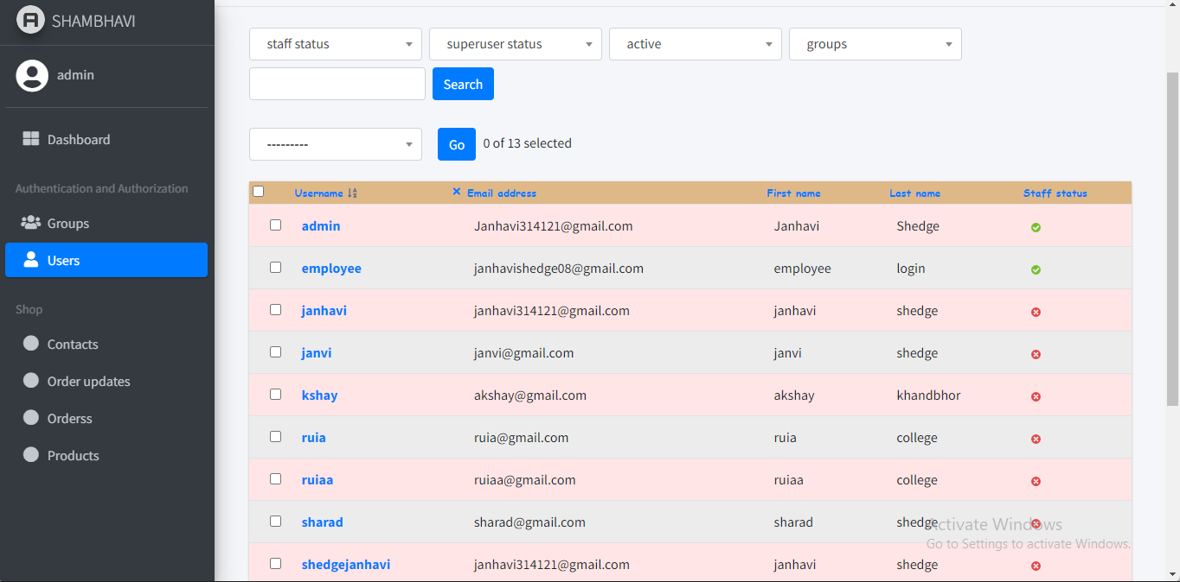

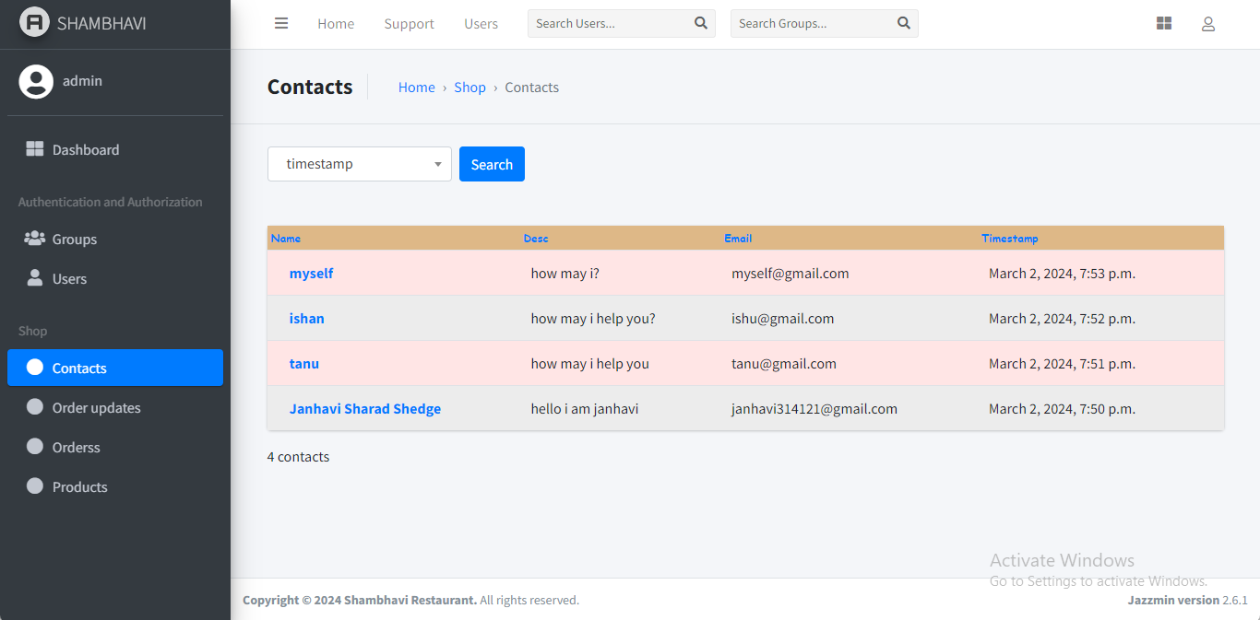

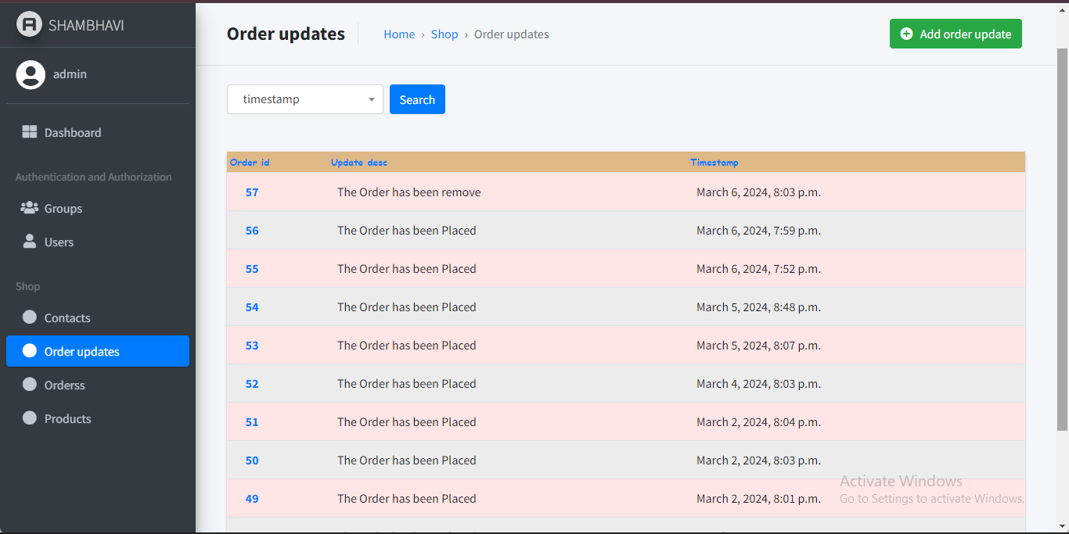

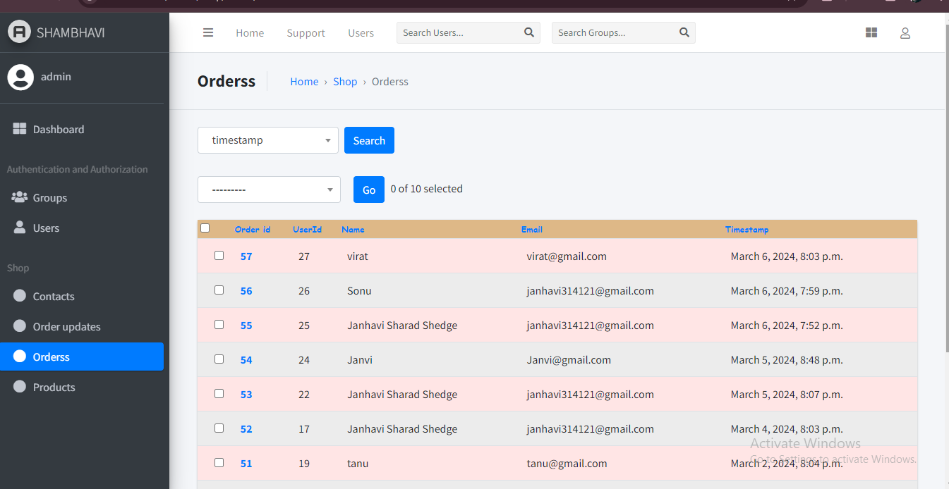

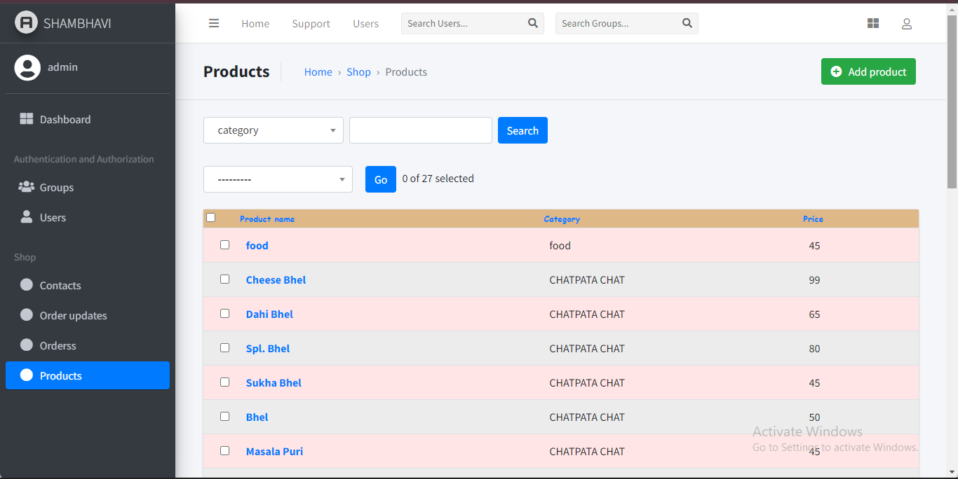

**6}IMPLEMENTATION DETAILS**

**6.1}Software/Hardware Details:**

Software/hardware specifications

**Technologies:**

• Django

• Python

• Bootstrap

• HTML

**• CSS Tools:**

• Git

• Visual Studio Code

• Pycharm

**6.2}Source Code:**

About.html:

{% extends 'shop/basic.html' %}

{% block title%} About Us - Shambhavi{% endblock %}

{% block body %}

  {% load static %}

  <!-- Google Fonts -->

  <link href="https://fonts.googleapis.com/css?family=Open+Sans:300,300i,400,400i,600,600i,700,700i|Roboto:300,300i,400,400i,500,500i,700,700i|Poppins:300,300i,400,400i,500,500i,600,600i,700,700i" rel="stylesheet">

  <!-- Vendor CSS Files -->

  <link href="{% static 'shop/assets/vendor/bootstrap/css/bootstrap.min.css' %}" rel="stylesheet">

  <link href="{% static 'shop/assets/vendor/icofont/icofont.min.css' %}" rel="stylesheet">

  <link href="{% static 'shop/assets/vendor/animate.css/animate.min.css' %}" rel="stylesheet">

  <!-- Template Main CSS File -->

  <link href="{% static 'shop/assets/css/style.css' %}" rel="stylesheet">

    <!-- ======= Hero Section ======= -->

  <section id="hero">

    <div class="hero-container">

      <div id="heroCarousel" class="carousel slide carousel-fade" data-ride="carousel">

        <ol class="carousel-indicators" id="hero-carousel-indicators"></ol>

        <div class="carousel-inner" role="listbox">

          <!-- Slide 1 -->

          <div class="carousel-item active">

            <div class="carousel-background"><img src="{% static 'shop/assets/img/slide/slide-1.jpg' %}" alt=""></div>

            <div class="carousel-container">

              <div class="carousel-content">

                <h2 class="animate__animated animate__fadeInDown">Welcome to <span>Shambhavi</span></h2>

                <a href="/shop/" class="btn-get-started animate__animated animate__fadeInUp scrollto">Get Started</a>

              </div>

            </div>

          </div>

          <!-- Slide 2 -->

          <div class="carousel-item">

            <div class="carousel-background"><img src="{% static 'shop/assets/img/slide/slide-2.jpg' %}" alt=""></div>

            <div class="carousel-container">

              <div class="carousel-content">

                <h2 class="animate__animated animate__fadeInDown mb-0">Our Mission</h2>

                <p class="animate__animated animate__fadeInUp">To be number one</p>

                <a href="/shop/" class="btn-get-started animate__animated animate__fadeInUp scrollto">Get Started</a>

              </div>

            </div>

          </div>

          <!-- Slide 3 -->

          <div class="carousel-item">

            <div class="carousel-background"><img src="{% static 'shop/assets/img/slide/slide-3.jpg' % %}" alt=""></div>

            <div class="carousel-container">

              <div class="carousel-content">

                <h2 class="animate__animated animate__fadeInDown mb-0">Ambiance and Dining Experience</h2>

                <p class="animate__animated animate__fadeInUp">Memorable Dining</p>

                <a href="/shop/" class="btn-get-started animate__animated animate__fadeInUp scrollto">Get Started</a>

              </div>

            </div>

          </div>

          <!-- Slide 4 -->

          <div class="carousel-item">

            <div class="carousel-background"><img src="{% static 'shop/assets/img/slide/slide-4.jpeg' %}" alt=""></div>

            <div class="carousel-container">

              <div class="carousel-content">

                <h2 class="animate__animated animate__fadeInDown mb-0">Specialities and Signature Dishes</h2>

                <p class="animate__animated animate__fadeInUp">Home Favourites</p>

                <a href="/shop/" class="btn-get-started animate__animated animate__fadeInUp scrollto">Get Started</a>

              </div>

            </div>

          </div>

          <!-- Slide 5 -->

          <div class="carousel-item">

            <div class="carousel-background"><img src="{% static 'shop/assets/img/slide/slide-5.jpeg' %}" alt=""></div>

            <div class="carousel-container">

              <div class="carousel-content">

                <h2 class="animate__animated animate__fadeInDown mb-0">Fresh and Local Ingredients</h2>

                <p class="animate__animated animate__fadeInUp">Farm-to-Table</p>

                <a href="/shop/" class="btn-get-started animate__animated animate__fadeInUp scrollto">Get Started</a>

              </div>

            </div>

          </div>

        <a class="carousel-control-prev" href="#heroCarousel" role="button" data-slide="prev">

          <span class="carousel-control-prev-icon icofont-thin-double-left" aria-hidden="true"></span>

          <span class="sr-only">Previous</span>

        </a>

        <a class="carousel-control-next" href="#heroCarousel" role="button" data-slide="next">

          <span class="carousel-control-next-icon icofont-thin-double-right" aria-hidden="true"></span>

          <span class="sr-only">Next</span>

        </a>

      </div>

    </div>

  </section><!-- End Hero -->

   <main id="main">

    <!-- ======= About Us Section ======= -->

    <section id="about" class="about">

      <div class="container">

        <div class="section-title">

          <h2>About Us</h2>

        </div>

        <div class="row">

          <div class="col-lg-6">

            <h3>Welcome to <strong>Shambhavi</strong></h3>

            <p class="font-italic">

              Shambhavi, founded in 1999 in Badlapur, Thane, Mumbai, is a distinguished establishment committed to delivering unparalleled hospitality. Our strategic location at Shop No. 9 Shree Yash Building, Badlapur-421503, near Cottonking Shop, ensures optimal accessibility. Placing patrons at the forefront, we prioritize their needs in every aspect of our operations. For inquiries or assistance, feel free to contact us during our business hours. Choose Shambhavi for an exquisite blend of commitment to excellence and highest standards in hospitality.

            </p>

          </div>

          <div class="col-lg-6 pt-4 pt-lg-0 content">

            <div class="skills-content">

              <p><b>Rating: </b></p>

              <div class="progress">

                <span class="skill">5 star <i class="val">93%</i></span>

                <div class="progress-bar-wrap">

                  <div class="progress-bar" role="progressbar" aria-valuenow="93" aria-valuemin="0" aria-valuemax="100"></div>

                </div>

              </div>

              <div class="progress">

                <span class="skill">4 star <i class="val">90%</i></span>

                <div class="progress-bar-wrap">

                  <div class="progress-bar" role="progressbar" aria-valuenow="90" aria-valuemin="0" aria-valuemax="100"></div>

                </div>

              </div>

              <div class="progress">

                <span class="skill">3 star <i class="val">30%</i></span>

                <div class="progress-bar-wrap">

                  <div class="progress-bar" role="progressbar" aria-valuenow="30" aria-valuemin="0" aria-valuemax="100"></div>

                </div>

              </div>

              <div class="progress">

                <span class="skill">2 star <i class="val">5%</i></span>

                <div class="progress-bar-wrap">

                  <div class="progress-bar" role="progressbar" aria-valuenow="5" aria-valuemin="0" aria-valuemax="100"></div>

                </div>

              </div>

              <div class="progress">

                <span class="skill">1 star <i class="val">0%</i></span>

                <div class="progress-bar-wrap">

                  <div class="progress-bar" role="progressbar" aria-valuenow="0" aria-valuemin="0" aria-valuemax="100"></div>

                </div>

              </div>

            </div>

          </div>

        </div>

      </div>

    </section><!-- End About Us Section -->

    <!-- ======= Counts Section ======= -->

    <section class="counts section-bg">

      <div class="container">

        <div class="row no-gutters">

          <div class="col-lg-3 col-md-6 d-md-flex align-items-md-stretch">

            <div class="count-box">

              <i class="icofont-simple-smile"></i>

              <span data-toggle="counter-up">10,000</span>

              <p><strong>Happy Customers</strong></p>

            </div>

          </div>

          <div class="col-lg-3 col-md-6 d-md-flex align-items-md-stretch">

            <div class="count-box">

              <i class="icofont-document-folder"></i>

              <span data-toggle="counter-up">155</span>

              <p><strong>Items</strong></p>

            </div>

          </div>

          <div class="col-lg-3 col-md-6 d-md-flex align-items-md-stretch">

            <div class="count-box">

              <i class="icofont-live-support"></i>

              <span data-toggle="counter-up">2,871</span>

              <p><strong>Hours Of Support</strong></p>

            </div>

          </div>

          <div class="col-lg-3 col-md-6 d-md-flex align-items-md-stretch">

            <div class="count-box">

              <i class="icofont-users-alt-5"></i>

              <span data-toggle="counter-up">11</span>

              <p><strong>Hard Workers</strong></p>

            </div>

          </div>

        </div>

      </div>

    </section><!-- End Counts Section -->

    <!-- ======= Our Team Section ======= -->

    <section id="team" class="team">

      <div class="container">

        <div class="section-title">

          <h2>Our Team</h2>

        </div>

        <div class="row" style="padding-left: 379px;">

          <div class="col-xl-3 col-lg-4 col-md-6" data-wow-delay="0.1s">

            <div class="member">

              <img src="{% static 'shop/assets/img/team/team-5.jpg' %}" class="img-fluid" alt="">

              <div class="member-info">

                <div class="member-info-content">

                  <h4></h4>

                </div>

              </div>

            </div>

          </div>

          <div class="col-xl-3 col-lg-4 col-md-6" data-wow-delay="0.2s">

            <div class="member">

              <img src="{% static 'shop/assets/img/team/team-7.jpg' %}" class="img-fluid" alt="">

              <div class="member-info">

                <div class="member-info-content">

                  <h4></h4>

                </div>

              </div>

            </div>

          </div>

        </div>

      </div>

    </section><!-- End Our Team Section -->

    <!-- ----FAQ STTART--- -->

    <!DOCTYPE html>

<html>

<head>

    <style>

        body {

            background-color: rgb(255, 255, 255);

        }

        .layout {

            width: 1000px;

            margin: auto;

        }

        .accordion {

            padding: 10px;

            margin-top: 10px;

            margin-bottom: 10px;

            background: rgb(105, 206, 105);

            border-radius: 10px;

        }

        .accordion__question p {

            margin: 5px;

            padding: 0;

            font-family: Verdana;

            font-size: 20px;

        }

        .accordion__answer p {

            margin: 5px;

            padding: 10px;

            font-size: large;

            font-family: Verdana, Geneva, Tahoma, sans-serif;

            color: rgb(255, 255, 255);

            background: rgb(82, 170, 122);

            border-radius: 10px;

        }

        .accordion:hover {

            cursor: pointer;

        }

        .accordion__answer {

            display: none;

        }

        .accordion.active .accordion__answer {

            display: block;

        }

    </style>

    <script>

        window.onload = function () {

            let answers = document.querySelectorAll(".accordion");

            answers.forEach((event) => {

                event.addEventListener("click", () => {

                    if (event.classList.contains("active")) {

                        event.classList.remove("active");

                    } else {

                        event.classList.add("active");

                    }

                });

            });

        }

    </script>

</head>

<body>

    <h2 style="color:rgba(71, 75, 71, 0.884); text-align:center">

        FAQ

    </h2>

    <div class="layout">

        <div class="accordion">

            <div class="accordion__question">

                <p>Do you offer vegetarian or vegan options?</p>

            </div>

            <div class="accordion__answer">

                <p>Yes, we offer a variety of vegetarian dishes on our menu. Our chefs are dedicated to providing delicious options for all dietary preferences.</p>

            </div>

        </div>

        <div class="accordion">

            <div class="accordion__question">

                <p>Are your ingredients locally sourced or organic?</p>

            </div>

            <div class="accordion__answer">

                <p>We prioritize sourcing fresh, high-quality ingredients for our dishes. While not all of our ingredients are organic, we strive to support local farmers and suppliers whenever possible.</p>

            </div>

        </div>

        <div class="accordion">

          <div class="accordion__question">

              <p>Do you cater for events?</p>

          </div>

          <div class="accordion__answer">

              <p> Yes, we offer catering services for events of all sizes. Please contact us through our website's Contact Us section to discuss your event requirements.</p>

          </div>

      </div>

      <div class="accordion">

        <div class="accordion__question">

            <p> Is there parking available near the restaurant?</p>

        </div>

        <div class="accordion__answer">

            <p>Unfortunately, we do not have parking facilities directly available near the restaurant. However, there may be street parking or public parking lots available nearby for your convenience.</p>

        </div>

    </div>

    </div>

</body>

</html>

    <!-- -----Faq end----- -->

    <!DOCTYPE html>

<html lang="en">

<head>

  <title>Footer Design</title>

  <meta charset="utf-8">

  <meta name="viewport" content="width=device-width, initial-scale=1">

  <link rel="stylesheet" href="https://fonts.googleapis.com/css2?family=Poppins:wght@300;400;500;600;700&display=swap">

  <link rel="stylesheet" type="text/css" href="https://cdnjs.cloudflare.com/ajax/libs/font-awesome/5.15.1/css/all.min.css">

  <style>

    body {

      line-height: 1.5;

      font-family: 'Poppins', sans-serif;

      margin: 0;

      padding: 0;

      box-sizing: border-box;

    }

    .container {

      max-width: 1170px;

      margin: auto;

    }

    .row {

      display: flex;

      flex-wrap: wrap;

    }

    ul {

      list-style: none;

    }

    .footer {

      background-color: #24262b;

      padding: 40px 0; /* Decreased the padding (height) */

    }

    .footer-col {

      width: 25%;

      padding: 0 15px;

    }

    .footer-col h4 {

      font-size: 18px;

      color: #ffffff;

      text-transform: capitalize;

      margin-bottom: 35px;

      font-weight: 500;

      position: relative;

    }

    .footer-col h4::before {

      content: '';

      position: absolute;

      left: 0;

      bottom: -10px;

      background-color: #e91e63;

      height: 2px;

      box-sizing: border-box;

      width: 50px;

    }

    .footer-col ul li:not(:last-child) {

      margin-bottom: 10px;

    }

    .footer-col ul li a {

      font-size: 16px;

      text-transform: capitalize;

      color: lightgray;

      text-decoration: none;

      font-weight: 300;

      transition: all 0.3s ease;

    }

    .footer-col ul li a:hover {

      color: lightgray;

      padding-left: 8px; /* Add slight padding on hover */

    }

    .footer-col .social-links a {

      display: inline-block;

      height: 40px;

      width: 40px;

      background-color: rgba(255, 255, 255, 0.2);

      margin: 0 10px 10px 0;

      text-align: center;

      line-height: 40px;

      border-radius: 50%;

      color: #ffffff;

      transition: all 0.5s ease;

    }

    .footer-col .social-links a:hover {

      color: #24262b;

      background-color: #ffffff;

    }

    /* Global styles for footer links */

    .footer-col ul li a {

      color: white;

      text-decoration: none;

      font-family: 'Poppins', sans-serif;

    }

    .footer-col ul li a:hover {

      color: lightgray;

    }

    /* Responsive adjustments */

    @media(max-width: 767px) {

      .footer-col {

        width: 50%;

        margin-bottom: 30px;

      }

    }

    @media(max-width: 574px) {

      .footer-col {

        width: 100%;

      }

    }

  </style>

</head>

<body>

  <footer class="footer">

    <div class="container">

      <div class="row">

        <div class="footer-col">

          <h4>Get Help</h4>

          <ul>

            <li><a href="/shop/about">About Us</a></li>

            <li><a href="/shop">Menus</a></li>

            <li><a href="/shop/tracker">Tracker</a></li>

            <li><a href="/shop/orderView/">Your Orders</a></li>

            <li><a href="/shop/contact">Contact Us</a></li>

          </ul>

        </div>

        <div class="footer-col">

          <h4>Contact Us</h4>

          <ul>

            <li style="color: lightgray;"><i class="fas fa-map-marker-alt"></i> Address: Shambahvi,Badlapur(East)-421503</li>

            <li style="color: lightgray;"><i class="fas fa-phone"></i> Phone: 9028672567</li>

          </ul>

        </div>

        <div class="footer-col">

          <ul style="color: transparent;">

          </ul>

        </div>

        <div class="footer-col">

          <h4>Opening Hours</h4>

          <ul>

            <li style="color: lightgray;">Monday 12–11 pm</li>

            <li style="color: lightgray;">Tuesday 12–11 pm</li>

            <li style="color: lightgray;">Wednesday 12–11 pm</li>

            <li style="color: lightgray;">Thursday 12–11 pm</li>

            <li style="color: lightgray;">Friday 12–11 pm</li>

            <li style="color: lightgray;">Saturday 12–11 pm</li>

            <li style="color: lightgray;">Sunday 12–11 pm</li>

          </ul>

        </div>

        <!-- <------Chatbot starts----->

          <script type="text/javascript">

            (function(d, m){

                var kommunicateSettings =

                    {"appId":"a0ddafcc9f8525f7625bd3f68fbbe63d","popupWidget":true,"automaticChatOpenOnNavigation":true};

                var s = document.createElement("script"); s.type = "text/javascript"; s.async = true;

                s.src = "https://widget.kommunicate.io/v2/kommunicate.app";

                var h = document.getElementsByTagName("head")[0]; h.appendChild(s);

                window.kommunicate = m; m._globals = kommunicateSettings;

            })(document, window.kommunicate || {});

        /* NOTE : Use web server to view HTML files as real-time update will not work if you directly open the HTML file in the browser. */

        </script>

<!-- <------Chatbot ends----->

      </div>

    </div>

  </footer

  </body>

</html>

   </main>

{% endblock %

{% block js %}

<script>

$('#popcart').popover();

updatePopover(cart);

function updatePopover(cart) {

    var popStr = "";

    popStr = popStr + "<h5> Click <a href='/shop/checkout'><button class='btn btn-primary'>Here</button></a> to order </h5><div class='mx-2 my-2'>";

    document.getElementById("popcart").setAttribute('data-content', popStr);

    $('#popcart').popover();

}

</script>

{% load static %}

  <!-- Vendor JS Files -->

  <script src="{% static 'shop/assets/vendor/jquery/jquery.min.js' %}"></script>

  <script src="{% static 'shop/assets/vendor/bootstrap/js/bootstrap.bundle.min.js' %}"></script>

  <script src="{% static 'shop/assets/vendor/jquery-sticky/jquery.sticky.js' %}"></script>

  <script src="{% static 'shop/assets/vendor/waypoints/jquery.waypoints.min.js' %}"></script>

  <script src="{% static 'shop/assets/vendor/counterup/counterup.min.js' %}"></script>

  <!-- Template Main JS File -->

  <script src="{% static 'shop/assets/js/main.js' %}"></script>

{% endblock %}

Basic.html:

<!DOCTYPE html>

<html lang="en">

<head>

    <!-- Required meta tags -->

    <meta charset="utf-8">

    <meta name="viewport" content="width=device-width, initial-scale=1, shrink-to-fit=no">

    <!-- Bootstrap CSS -->

    <link rel="stylesheet" href="https://stackpath.bootstrapcdn.com/bootstrap/4.2.1/css/bootstrap.min.css"

        integrity="sha384-GJzZqFGwb1QTTN6wy59ffF1BuGJpLSa9DkKMp0DgiMDm4iYMj70gZWKYbI706tWS"

        crossorigin="anonymous">

    <link rel="stylesheet" href="https://stackpath.bootstrapcdn.com/bootstrap/4.3.1/css/bootstrap.min.css"

        integrity="sha384-ggOyR0iXCbMQv3Xipma34MD+dH/1fQ784/j6cY/iJTQUOhcWr7x9JvoRxT2MZw1T"

        crossorigin="anonymous">

    <link rel="stylesheet" href="https://use.fontawesome.com/releases/v5.8.2/css/all.css"

        integrity="sha384-oS3vJWv+0UjzBfQzYUhtDYW+Pj2yciDJxpsK1OYPAYjqT085Qq/1cq5FLXAZQ7Ay"

        crossorigin="anonymous">

    <title>{% block title%} {% endblock %}</title>

    <link rel="icon" href="http://127.0.0.1:8000/media/shop/images/logo2.png" type="image/x-icon">

    <style>

        .navbar-brand img {

            max-height: 50px; /* Adjust the height as needed */

            padding-right: 10px; /* Add some spacing between logo and text */

        }

        .navbar-brand span {

            font-size: 24px; /* Adjust the font size as needed */

            font-weight: bold; /* Make the text bold */

        }

        .popover-header {

            background-color: #dfd7d7;

        }

        {% block css %} {% endblock %}

    </style>

</head>

<body>

    <nav class="navbar navbar-expand-lg navbar-dark bg-dark">

        <a class="navbar-brand" href="/shop">

            <img src="http://127.0.0.1:8000/media/shop/images/logo2.png" alt="Logo">

            <span>Shambhavi</span>

        </a>

        <button class="navbar-toggler" type="button" data-toggle="collapse" data-target="#navbarSupportedContent"

            aria-controls="navbarSupportedContent" aria-expanded="false" aria-label="Toggle navigation">

            <span class="navbar-toggler-icon"></span>

        </button>

        <div class="collapse navbar-collapse" id="navbarSupportedContent">

            <ul class="navbar-nav mr-auto">

                <li class="nav-item">

                    <a class="nav-link" href="/shop/about">About Us </a>

                </li>

                <li class="nav-item">

                    <a class="nav-link" href="/shop">Menus <span class="sr-only">(current)</span></a>

                </li>

                <li class="nav-item dropdown" id="categoryList">

                </li>

                <li class="nav-item">

                    <a class="nav-link" href="/shop/tracker">Tracker</a>

                </li>

                <li class="nav-item">

                    <a class="nav-link" href="/shop/orderView/">Your Orders</a>

                </li>

                <li class="nav-item">

                    <a class="nav-link" href="/shop/contact">Contact Us</a>

                </li>

            </ul>

            <form method="get" action="/shop/search" class="form-inline my-2 my-lg-0 mx-3">

                <input class="form-control mr-sm-2" type="search" name="search" id="search" placeholder="Search"

                    aria-label="Search" required>

                <button class="btn btn-outline-success my-2 my-sm-0" type="submit">Search</button>

            </form>

            {% if user.is_authenticated %}

            <ul class="navbar-nav mr-2">

                <li class="nav-item dropdown">

                    <a class="nav-link dropdown-toggle" href='#' id="navbarDropdown" role="button"

                        data-toggle="dropdown"> Welcome {{request.user}}</a>

                    <div class="dropdown-menu" aria-labelledby="navbarDropdown">

                        <a class="dropdown-item" href="/shop/logout/">Logout</a>

                    </div>

                </li>

            </ul>

            {% else %}

            <!-- Button trigger Login modal -->

            <button type="button" class="btn btn-success mx-2" data-toggle="modal" data-target="#loginModal">Login</button>

            <!-- Button trigger Signup modal -->

            <button type="button" class="btn btn-success mx-2" data-toggle="modal"

                data-target="#signupModal">SignUp</button>

            {% endif %}

            <button type="button" class="btn btn-secondary mx-2" id="popcart" data-container="body" data-html="true"

                data-toggle="popover" title="MyCart" data-placement="bottom" data-content="Bottom popover">

                Cart(<span id="cart">0</span>)

            </button>

        </div>

    </nav>

    <!-- Login Modal -->

<div class="modal fade" id="loginModal" tabindex="-1" role="dialog" aria-labelledby="loginModal" aria-hidden="true">

    <div class="modal-dialog" role="document">

        <div class="modal-content">

            <div class="modal-header" style="background-color: rgb(111 202 203);">

                <h5 class="modal-title" id="loginModalTitle">Login Here</h5>

                <button type="button" class="close" data-dismiss="modal" aria-label="Close">

                    <span aria-hidden="true">&times;</span>

                </button>

            </div>

            <div class="modal-body">

                <form id="loginForm" action="/shop/login/" method="post">

                    {% csrf_token %}

                    <div class="text-left my-2">

                        <b><label for="loginusername">Username</label></b>

                        <input class="form-control" id="loginusername" name="loginusername" placeholder="Enter Your Username" type="text" required pattern="^[a-z]{3,15}$">

                    </div>

                    <div class="text-left my-2">

                        <b><label for="loginpassword">Password</label></b>

                        <input class="form-control" id="loginpassword" name="loginpassword" placeholder="Enter Your Password" type="password" required data-toggle="password">

                    </div>

                    <button type="submit" class="btn btn-success">Submit</button>

                    <a href="/shop/reset_password/" style="padding-left: 210px;">Forgot password?</a>

                </form>

                <p class="mb-0 mt-1">Don't have an account? <a href="#" data-dismiss="modal" data-toggle="modal" data-target="#signupModal">Sign up now</a>.</p>

            </div>

        </div>

    </div>

</div>

<script>

    document.getElementById('loginForm').addEventListener('submit', function(event) {

        var username = document.getElementById('loginusername').value;

        var password = document.getElementById('loginpassword').value;

        if (username === 'admin' && password === 'owner@12345') {

            // Redirect to Admin Login

            window.location.href = '/admin';

            event.preventDefault(); // Prevent form submission

        } else if (username === 'employee' && password === 'Emp@12345') {

            // Redirect to Employe Login

            window.location.href = '/admin';

            event.preventDefault(); // Prevent form submission

        } else {

            // Proceed with form submission

        }

    });

</script>

    <!-- Sign up Modal -->

    <div class="modal fade" id="signupModal" tabindex="-1" role="dialog" aria-labelledby="signupModal"

        aria-hidden="true">

        <div class="modal-dialog" role="document">

            <div class="modal-content">

                <div class="modal-header" style="background-color: rgb(111 202 203);">

                    <h5 class="modal-title" id="signupModal">SignUp Here</h5>

                    <button type="button" class="close" data-dismiss="modal" aria-label="Close">

                        <span aria-hidden="true">&times;</span>

                    </button>

                </div>

                <div class="modal-body">

                    <form action="/shop/signup/" method="post" id="signupForm">

                        {% csrf_token %}

                        <div class="form-group">

                            <b><label for="username">Username</label></b>

                            <input class="form-control" id="username" name="username"

                                placeholder="Choose a unique Username" type="text" required pattern="^[a-z]{3,15}$">

                        </div>

                        <div class="form-row">

                            <div class="form-group col-md-6">

                                <b><label for="f_name">First Name:</label></b>

                                <input type="text" class="form-control" id="f_name" name="f_name"

                                    placeholder="First Name" required>

                            </div>

                            <div class="form-group col-md-6">

                                <b><label for="l_name">Last name:</label></b>

                                <input type="text" class="form-control" id="l_name" name="l_name"

                                    placeholder="Last name" required>

                            </div>

                        </div>

                        <div class="form-group">

                            <b><label for="email1">Email:</label></b>

                            <input type="email" class="form-control" id="email1" name="email1"

                                placeholder="Enter Your Email" required>

                        </div>

                        <div class="form-group">

                            <b><label for="phone">Phone No:</label></b>

                            <div class="input-group mb-3">

                                <div class="input-group-prepend">

                                    <span class="input-group-text" id="basic-addon">+91</span>

                                </div>

                                <input type="tel" class="form-control" id="phone" name="phone"

                                    placeholder="Enter Your Phone Number" required pattern="[0-9]{10}">

                            </div>

                        </div>

                        <div class="text-left my-2">

                            <b><label for="password">Password:</label></b>

                            <input class="form-control" id="password" name="password" placeholder="Enter Password"

                                type="password" required data-toggle="password" oninput="checkPasswordStrength()">

                            <small id="passwordHelp" class="form-text text-muted">

                                Password should be at least 9 characters long, including uppercase letters, lowercase

                                letters, numbers, and symbols.

                            </small>

                        </div>

                        <div class="text-left my-2">

                            <b><label for="password1">Re-enter Password:</label></b>

                            <input class="form-control" id="password1" name="password1"

                                placeholder="Re-enter Password" type="password" required data-toggle="password">

                        </div>

                        <button type="submit" class="btn btn-success" id="submitBtn" disabled>Submit</button>

                    </form>

                    <p class="mb-0 mt-1">Already have an account? <a href="#" data-dismiss="modal"

                            data-toggle="modal" data-target="#loginModal">Login here</a>.</p>

                </div>

            </div>

        </div>

    </div>

    {% if messages %}

    {% for message in messages %}

    <div class="alert alert-{{ message.tags }} alert-dismissible mb-0" role="alert">

        <button type="button" class="close" data-dismiss="alert"><span aria-hidden="true">×</span></button>

        {{ message }}

    </div>

    {% endfor %}

    {% endif %}

    {% block body %} {% endblock %}

    <!-- Optional JavaScript -->

    <!-- jQuery first, then Popper.js, then Bootstrap JS -->

    <script src="https://code.jquery.com/jquery-3.5.1.js"

        integrity="sha256-QWo7LDvxbWT2tbbQ97B53yJnYU3WhH/C8ycbRAkjPDc=" crossorigin="anonymous"></script>

    <script src="https://cdnjs.cloudflare.com/ajax/libs/popper.js/1.14.6/umd/popper.min.js"

        integrity="sha384-wHAiFfRlMFy6i5SRaxvfOCifBUQy1xHdJ/yoi7FRNXMRBu5WHdZYu1hA6ZOblgut"

        crossorigin="anonymous"></script>

    <script src="https://stackpath.bootstrapcdn.com/bootstrap/4.2.1/js/bootstrap.min.js"

        integrity="sha384-B0UglyR+jN6CkvvICOB2joaf5I4l3gm9GU6Hc1og6Ls7i6U/mkkaduKaBhlAXv9k"

        crossorigin="anonymous"></script>

    <script src="https://unpkg.com/bootstrap-show-password@1.2.1/dist/bootstrap-show-password.min.js"></script>

    <script>

        function checkPasswordStrength() {

            var password = document.getElementById('password').value;

            var passwordHelp = document.getElementById('passwordHelp');

            var submitBtn = document.getElementById('submitBtn');

            var conditionsMet = true;

            // Check length

            if (password.length < 9) {

                conditionsMet = false;

                passwordHelp.innerText = 'Password should be at least 9 characters long.';

            } else {

                passwordHelp.innerText = '';

            }

            // Check if password contains uppercase letters

            if (!/[A-Z]/.test(password)) {

                conditionsMet = false;

                passwordHelp.innerText += '\nPassword should contain at least one uppercase letter.';

            }

            // Check if password contains lowercase letters

            if (!/[a-z]/.test(password)) {

                conditionsMet = false;

                passwordHelp.innerText += '\nPassword should contain at least one lowercase letter.';

            }

            // Check if password contains numbers

            if (!/\d/.test(password)) {

                conditionsMet = false;

                passwordHelp.innerText += '\nPassword should contain at least one number.';

            }

            // Check if password contains symbols

            if (!/[!@#$%^&*(),.?":{}|<>]/.test(password)) {

                conditionsMet = false;

                passwordHelp.innerText += '\nPassword should contain at least one symbol.';

            }

            // Enable or disable the submit button based on conditionsMet

            submitBtn.disabled = !conditionsMet;

        }

    </script>

    {% block js %} {% endblock %}

</body>

</html>

Checkout.html:

{% extends 'shop/basic.html' %}

{% block title%} Checkout - Shambhavi{% endblock %}

{% block css %}

    #cont {

        min-height : 609px;

    }

    #cont2 {

        min-height : 626px;

    }

{% endblock %}

{% block body %}

{% if user.is_authenticated %}

<div class="container" id="cont">

    <div class="col my-3">

        <span id="title"><h2> My Awesome Cart Express Checkout - Review Your Cart items </h2></span>

        <div class="my-2">

            <ul class="list-group" id='items'>

            </ul>

        </div>

    </div>

    <div class="col my-4">

        <span id="info">

        <h2>{{ request.user.first_name }} Enter Address & Other Details</h2>

        <form method="post" action="/shop/checkout/">{% csrf_token %}

            <input type="hidden" name="itemsJson" id="itemsJson">

            <input type="hidden" name="amount" id="amount">

            <input type="hidden" name="user_id" id="user_id" value="{{ request.user.id }}">

            <div class="form-row">

                <div class="form-group col-md-6">

                    <label for="name">Name</label>

                    <input type="text" class="form-control" id="name" name="name" placeholder="Name" required>

                </div>

                <div class="form-group col-md-6">

                    <label for="Email">Email</label>

                    <input type="email" class="form-control" id="email" name="email" placeholder="abc@gmail.com" required>

                </div>

            </div>

            <div class="form-group">

                <label for="Address1">Address</label>

                <input type="text" class="form-control" id="address1" name="address1" placeholder="1234 Main St" required>

            </div>

            <div class="form-group">

                <label for="Address2">Address Line 2</label>

                <input type="text" class="form-control" id="address2" name="address2" placeholder="Apartment, studio, or floor">

            </div>

            <div class="form-row">

                <div class="form-group col-md-6">

                    <label for="City">City</label>

                    <input type="text" class="form-control" id="city" name="city" placeholder="Surat" required>

                </div>

                <div class="form-group col-md-4">

                    <label for="State">State</label>

                    <input type="text" class="form-control" id="state" name="state" placeholder="Gujarat" required>

                </div>

                <div class="form-group col-md-2">

                    <label for="zip_code">Zip</label>

                    <input type="text" class="form-control" id="zip_code" name="zip_code" placeholder="xxxxxx" required pattern="[0-9]{6}">

                </div>

            </div>

            <div class="form-group">

                <label for="phone">Phone Number</label>

                <input type="tel" class="form-control" id="phone" name="phone" placeholder="xxxxxxxxxxx" required pattern="[0-9]{10}">

            </div>

            <div class="alert alert-info">

              <strong>Info!</strong> online payment are currently disabled so please choose cash on delivery.

            </div>

            <button type="submit" class="btn btn-primary" name="onlinePay" disabled>Online Pay</button>

            <button type="submit" class="btn btn-primary" name="cashOnDelivery">Cash On Delivery</button>

        </form>

        </span>

    </div>

</div>

{% else %}

    <div id="cont2">

        <div class="alert alert-info">

            <font style="font-size:22px"><center>Before checkout you need to <strong><a class="alert-link" data-toggle="modal" data-target="#loginModal">Login</a></strong></center></font>

        </div>

    </div>

{% endif %}

{% endblock %}

{% block js %}

<script>

if (localStorage.getItem('cart') == null) {

    var cart = {};

} else {

    cart = JSON.parse(localStorage.getItem('cart'));

}

// console.log(cart);

var sum = 0;

var sumPrice = 0;

var totalPrice = 0;

if ($.isEmptyObject(cart)) {

    // If object is empty

    mystr = "<div class='alert alert-info'><font style='font-size:22px'>"

    mystr = mystr + "<center>Your cart is <strong>Empty</strong>, please <strong>Add</strong> some items before checking out ! </center>"

    mystr = mystr + "<center>Click <a href='/shop/' class='alert-link'>Here</a> to Add items.</center></font></div>";

    $('#items').append(mystr);

    document.getElementById('info').innerHTML = "";

    document.getElementById('title').innerHTML = "";

} else {

    var i = 0;

    for (item in cart) {

        let name = cart[item][1];

        let qty = cart[item][0];

        let itemPrice = cart[item][2];

        sum = sum + qty;

        sumPrice = qty * itemPrice;

        totalPrice = totalPrice + sumPrice;

        mystr = `<li class="list-group-item d-flex justify-content-between align-items-center">${++i} : ${name}<span class="badge badge-primary badge-pill">${qty} x Rs. ${itemPrice} = Rs. ${sumPrice}</span></li>`;

        $('#items').append(mystr);

    }

    mystr = `<li class="list-group-item d-flex justify-content-between align-items-center" style="background: bisque;">Total Price:</span><span class="badge badge-danger badge-pill" id="totalPrice">Rs. ${totalPrice} /-</span></li>`;

    $('#items').append(mystr);

}

document.getElementById('cart').innerHTML = sum;

document.getElementById('totalPrice').innerHTML = totalPrice;

$('#itemsJson').val(JSON.stringify(cart));

$('#amount').val($('#totalPrice').html());

{% if thank %}

alert('Thanks for ordering with us. Your order id is {{id}}. Use it to track your order using our order tracker');

localStorage.clear();

document.location="/shop";

{%endif%}

//    /* restrict user browser click go back button */

//    function preback() { window.history.forward(); }

//    setTimeout("preback()", 0);

//    window.onunload = function() { null };

</script>

{% endblock %}

Contact.html:

{% extends 'shop/basic.html' %}

{% block title%} Contact Us - Shambhavi{% endblock %}

{% block css %}

.footer.container-fluid.bg-dark.text-light {

    position:fixed;

    bottom:0;

}

.contact2 {

    font-family: "Montserrat", sans-serif;

    color: #464646; /* Darker text color */

    font-weight: 300;

    background-position: center top;

}

.contact2 h1,

.contact2 h2,

.contact2 h3,

.contact2 h4,

.contact2 h5,

.contact2 h6 {

    color: #333; /* Darker headings */

}

.contact2 .font-weight-medium {

    font-weight: 500;

}

.contact2 .subtitle {

    color: #464646; /* Darker subtitle */

    line-height: 24px;

}

.contact2 .bg-image {

    background-size: cover;

    position: relative;

    display: -webkit-box;

    display: -webkit-flex;

    display: -ms-flexbox;

    display: flex;

}

.contact2 .card.card-shadow {

    box-shadow: 0px 0px 30px rgba(0, 0, 0, 0.1);

}

.contact2 .detail-box .round-social {

    margin-top: 100px;

}

.contact2 .round-social a {

    background: transparent;

    margin: 0 7px;

    padding: 11px 12px;

}

.contact2 .contact-container .links a {

    color: #464646; /* Darker links */

}

.contact2 .contact-container {

    position: relative;

    top: 107px;

}

.contact2 .btn-danger-gradiant {

    background: #ff4d7e;

    background: linear-gradient(to right, #ff4d7e 0%, #ff6a5b 100%);

    border: none;

    color: #fff;

    transition: all 0.3s ease;

}

.contact2 .btn-danger-gradiant:hover {

    background: #ff6a5b;

}

{% endblock %}

{% block body %}

<div class="contact2" style="background-image:url(http://127.0.0.1:8000/media/shop/images/map2.jpg);height: 400px;" id="contact">

  <div class="container">

    <div class="row contact-container">

      <div class="col-lg-12">

        <div class="card card-shadow border-0">

          <div class="row">

            <div class="col-lg-8">

              <div class="contact-box p-4">

                <div class="row">

                  <div class="col-lg-8">

                    <h4 class="title">Contact Us</h4>

                  </div>

                </div>

                <form action="/shop/contact/" method="POST">{% csrf_token %}

                  <div class="form-group mt-3">

                      <b><label for="name">Name:</label></b>

                      <input type="text" class="form-control" id="name" name="name" placeholder="Enter Your Name" required>

                  </div>

                  <div class="form-group mt-3">

                      <b><label for="email">Email:</label></b>

                      <input type="email" class="form-control" id="email" name="email" placeholder="Enter Your Email" required>

                  </div>

                  <div class="form-group mt-3">

                      <b><label for="phone">Phone No:</label></b>

                      <div class="input-group mb-3">

                          <div class="input-group-prepend">

                            <span class="input-group-text" id="basic-addon">+91</span>

                          </div>

                          <input type="tel" class="form-control" id="phone" name="phone" aria-describedby="basic-addon" placeholder="Enter Your Phone Number" required pattern="[0-9]{10}">

                      </div>

                  </div>

                  <div class="form-group mt-3">

                    <b><label for="desc">Message:</label></b>

                    <textarea class="form-control" id="desc" name="desc" rows="2" required minlength="6" placeholder="How May We Help You ?"></textarea>

                  </div>

                    <button type="submit" class="btn btn-danger-gradiant text-white border-0 py-2 px-3"><span> SUBMIT NOW <i class="ti-arrow-right"></i></span></button>

                </form>

              </div>

            </div>

            <div class="col-lg-4 bg-image" style="background-image:url(http://127.0.0.1:8000/media/shop/images/contact2.jpeg)">

                    <div class="detail-box p-4">

                      <h5 class="text-white font-weight-light mb-3">ADDRESS</h5>

                      <p class="text-white op-7">Shri Yash CHS,Shop Number 5,Badlapur,Thane,Maharashtra,India-421503 <br> </p>

                      <h5 class="text-white font-weight-light mb-3 mt-4">CALL US</h5>

                      <p class="text-white op-7">8149336671

                        <br> 9028672567</p>

                      <div class="round-social light">

                        <a href="https://www.google.com/maps/place/Shambhavi+Snacks+Pav+Bhaji/@19.1661307,73.2348764,17z/data=!3m1!4b1!4m6!3m5!1s0x3be792d33b523437:0x5ce345daacffdab1!8m2!3d19.1661257!4d73.2374513!16s%2Fg%2F1hm5ypdh7?authuser=0&entry=ttu" class="text-decoration-none text-white border border-white rounded-circle" target="_blank"><i class="fas fa-map-marker-alt"></i></a>

                      </div>

                    </div>

                  </div>

                  <!-- <------Chatbot starts----->

                    <!-- <script type="text/javascript">

                      (function(d, m){

                          var kommunicateSettings =

                              {"appId":"a0ddafcc9f8525f7625bd3f68fbbe63d","popupWidget":true,"automaticChatOpenOnNavigation":true};

                          var s = document.createElement("script"); s.type = "text/javascript"; s.async = true;

                          s.src = "https://widget.kommunicate.io/v2/kommunicate.app";

                          var h = document.getElementsByTagName("head")[0]; h.appendChild(s);

                          window.kommunicate = m; m._globals = kommunicateSettings;

                      })(document, window.kommunicate || {});

                  /* NOTE : Use web server to view HTML files as real-time update will not work if you directly open the HTML file in the browser. */

                  </script> -->

<!-- <------Chatbot ends----->

          </div>

        </div>

      </div>

    </div>

  </div>

</div>

{% endblock %}

{% block js %}

<script>

$('#popcart').popover();

updatePopover(cart);

function updatePopover(cart) {

    var popStr = "";

    popStr = popStr + "<h5> Click <a href='/shop/checkout'><button class='btn btn-primary'>Here</button></a> to order </h5><div class='mx-2 my-2'>";

    document.getElementById("popcart").setAttribute('data-content', popStr);

    $('#popcart').popover();

}

{% if thank %}

alert('Thanks for Contact with us. We will get back to you soon!');

document.location = "/shop/contact";

{% endif %}

</script>

{% endblock %}

Index.html:

{% extends 'shop/basic.html' %}

{% block title%} Home - Shambhavi{% endblock %}

{% block css %}

    .col-md-3

    {

        display: inline-block;

        margin-left:-4px;

    }

    .carousel-indicators .active {

        background-color: blue;

    }

    .col-md-3 img{

        width:227px;

        height:222px;

    }

    body .carousel-indicator li{

        background-color: blue;

    }

    body .carousel-indicators{

        bottom: -35px;

    }

    .carousel-indicators li{

        background-color: #7270fc;

    }

    body .carousel-control-prev-icon,

    body .carousel-control-next-icon{

        background-color: blue;

    }

    .carousel-control-prev,

    .carousel-control-next{

        top:auto;

        bottom:auto;

        padding-top:222px;

    }

    body .no-padding{

        padding-left: 0,

        padding-right: 0;

    }

    div.c {

        width: 1000px;

        margin: 10px;

        font-size: 20px;

        position: relative;

        left: 174px;

    }

{% endblock %}

  {% block body %}

  {% load static %}

<div class="container">

    <!--Slideshow starts here -->

    {% for product, range, nSlides in allProds %}

    <h3 class="my-4">{{product.0.category}}</h3>

    <div class="row">

        <div id="demo{{forloop.counter}}" class="col carousel slide my-3" data-ride="carousel">

            <ul class="carousel-indicators">

                <li data-target="#demo{{forloop.counter}}" data-slide-to="0" class="active"></li>

                {% for i in range %}

                <li data-target="#demo{{forloop.parentloop.counter}}" data-slide-to="{{i}}"></li>

                {% endfor %}

            </ul>

            <div class="container carousel-inner no-padding">

                <div class="carousel-item active">

                    {% for i in product %}

                    <div class="col-xs-3 col-sm-3 col-md-3">

                        <div class="card align-items-center" style="width: 18rem;">

                            <img src='/media/{{i.image}}' class="card-img-top" alt="...">

                            <div class="card-body">

                                <h5 class="card-title" id="namepr{{i.id}}">{{i.product_name|slice:"0:20"}}...</h5>

                                <h6 style="color: #ff0000">Rs. <i id="pricepr{{i.id}}">{{i.price}}</i>/-</h6>

                                <p class="card-text">{{i.desc|slice:"0:23"}}...</p>

                                <span id="divpr{{i.id}}" class="divpr">

                                    <button id="pr{{i.id}}" class="btn btn-primary cart">Add to Cart</button>

                                </span>

                                <a href="/shop/productView/{{i.id}}"> <button id="qv{{i.id}}" class="btn btn-primary cart">Quick View</button> </a>

                            </div>

                        </div>

                    </div>

                    {% if forloop.counter|divisibleby:4 and forloop.counter > 0 and not forloop.last %}

                </div>

                <div class="carousel-item">

                    {% endif %}

                    {% endfor %}

                </div>

            </div>

        </div>

        <!-- left and right controls for the slide -->

        <a class="carousel-control-prev" href="#demo{{forloop.counter}}" data-slide="prev">

            <span class="carousel-control-prev-icon"></span>

        </a>

        <a class="carousel-control-next" href="#demo{{forloop.counter}}" data-slide="next">

            <span class="carousel-control-next-icon"></span>

        </a>

    </div>

    {% endfor %}

    <!-- <------Chatbot starts----->

        <script type="text/javascript">

            (function(d, m){

                var kommunicateSettings =

                    {"appId":"a0ddafcc9f8525f7625bd3f68fbbe63d","popupWidget":true,"automaticChatOpenOnNavigation":true};

                var s = document.createElement("script"); s.type = "text/javascript"; s.async = true;

                s.src = "https://widget.kommunicate.io/v2/kommunicate.app";

                var h = document.getElementsByTagName("head")[0]; h.appendChild(s);

                window.kommunicate = m; m._globals = kommunicateSettings;

            })(document, window.kommunicate || {});

        /* NOTE : Use web server to view HTML files as real-time update will not work if you directly open the HTML file in the browser. */

        </script>

<!-- <------Chatbot ends----->

</div>

{% endblock %}

{% block js %}

<script>

// console.log({{request.user.id}});

if (localStorage.getItem('cart') == null) {

    var cart = {};

} else {

    cart = JSON.parse(localStorage.getItem('cart'));

    updateCart(cart);

}

// If the add to cart button is clicked, add/increment the item

$('.divpr').on('click', 'button.cart', function() {

    var idstr = this.id.toString();

    //console.log(idstr);

    if (cart[idstr] != undefined) {

        qty = cart[idstr][0] + 1;

    } else {

        qty = 1;

        name = document.getElementById('name'+idstr).innerHTML;

        price = document.getElementById('price'+idstr).innerHTML;

        cart[idstr] = [qty, name, parseInt(price)];

    }

    updateCart(cart);

});

$('#popcart').popover();

updatePopover(cart);

function updatePopover(cart) {

    var popStr = "";

    popStr = popStr + "<div class='mx-2 my-2'>";

    var i = 1;

    var j = 0;

    for(var item in cart) {

        popStr = popStr + "<b>" + i + "</b>. ";

        popStr = popStr + document.getElementById('name' + item).innerHTML.slice(0, 15) + "... (Qty: " + cart[item][0] + ')<br>';

        i = i + 1;

        j = j + 1;

    }

    if(j == 0) {

        popStr = popStr + "<p><b> No item available in your cart </b></p><div class='mx-2 my-2'>";

        popStr = popStr + "</div> <a href='/shop'><button class='btn btn-primary'>Add items</button></a> ";

    }

    else{

        popStr = popStr + "</div> <a href='/shop/checkout'><button class='btn btn-primary' id='checkout'>Checkout</button></a> <a href='/shop/'><button class='btn btn-primary' onclick='clearCart()' id='clearCart'>Clear Cart</button></a>  ";

    }

    document.getElementById("popcart").setAttribute('data-content', popStr);

    $('#popcart').popover();

}

function clearCart() {

  cart = JSON.parse(localStorage.getItem('cart'));

  for (var item in cart) {

    document.getElementById('div' + item).innerHTML = '<button id="'+ item +'" class="btn btn-primary cart">Add to Cart</button>'

  }

  localStorage.clear();

  cart = {};

  updateCart(cart);

}

function updateCart(cart) {

    //console.log(cart);

    var sum = 0;

    for (var item in cart) {

        sum = sum + cart[item][0];

        document.getElementById('div' + item).innerHTML = "<button id='minus" + item + "' class='btn btn-primary minus'>-</button> <span id='val" + item + "''>" + cart[item][0] + "</span> <button id='plus" + item + "' class='btn btn-primary plus'> + </button>";

    }

    localStorage.setItem('cart', JSON.stringify(cart));

    document.getElementById('cart').innerHTML = sum;

    updatePopover(cart);

}

$('.divpr').on("click", "button.minus", function() {

    //console.log("minus clicked");

    a = this.id.slice(7, );

    cart['pr' + a][0] = cart['pr' + a][0] - 1;

    cart['pr' + a][0] = Math.max(0, cart['pr' + a][0]);

    if(cart['pr' + a][0] == 0) {

        document.getElementById('divpr' + a).innerHTML = '<button id="pr'+a+'" class="btn btn-primary cart">Add to Cart</button>';

        delete cart['pr'+a];

    }

    else {

        document.getElementById('valpr' + a).innerHTML = cart['pr' + a][0];

    }

    updateCart(cart);

});

$('.divpr').on("click", "button.plus", function() {

    //console.log("plus clicked");

    a = this.id.slice(6, );

    cart['pr' + a][0] = cart['pr' + a][0] + 1;

    document.getElementById('valpr' + a).innerHTML = cart['pr' + a][0];

    updateCart(cart);

});

document.getElementById('categoryList').innerHTML = '<a class="nav-link dropdown-toggle" href="#" id="navbarDropdown" role="button" data-toggle="dropdown" aria-haspopup="true" aria-expanded="false">Categories</a><div class="dropdown-menu" aria-labelledby="navbarDropdown" >{% for product, range, nSlides in allProds %}<a class="dropdown-item" href="/shop/search/?search={{product.0.category}}">{{product.0.category}}</a>{% endfor %}</div>';

</script>

{% endblock %}

Login.html

<!DOCTYPE html>

<html lang="en">

<head>

    <meta charset="UTF-8">

    <title>login</title>

</head>

<body style="background-repeat: no-repeat; background-size: cover; background-image: url('https://serving.photos.photobox.com/67552147bcd0745d93af6849d11faea5fc318b1021a84a1366deccfe5efe0613fb30bcb5.jpg');">

    <div class="modal fade" id="loginModal" tabindex="-1" role="dialog" aria-labelledby="loginModal" aria-hidden="true">

      <div class="modal-dialog" role="document">

        <div class="modal-content">

          <div class="modal-header">

            <h5 class="modal-title" id="loginModal">Login Here</h5>

            <button type="button" class="close" data-dismiss="modal" aria-label="Close">

              <span aria-hidden="true">&times;</span>

            </button>

          </div>

          <div class="modal-body">

            <form action="/shop/login/" method="post">{% csrf_token %}

              <div class="text-left my-2">

                  <b><label for="username">Username</label></b>

                  <input class="form-control" id="loginusername" name="loginusername" placeholder="Enter Your Username" type="text" required pattern="^[a-z]{3,15}$">

              </div>

              <div class="text-left my-2">

                  <b><label for="password">Password</label></b>

                  <input class="form-control" id="loginpassword" name="loginpassword" placeholder="Enter Your Password" type="password" required data-toggle="password">

              </div>

              <button type="submit" class="btn btn-success">Submit</button>

            </form>

          </div>

        </div>

      </div>

    </div>

</body>

</html>

OrderView.html:

{% extends 'shop/basic.html' %}

{% block title%} Orders - Shambhavi{% endblock %}

{% block css %}

    /* Add CSS for light gray background */

    body {

        background-color: #f2f2f2; /* Light gray background */

    }

    /* Default styles for print */

    @media print {

        body {

            background-color: #fff; /* White background for print */

        }

        .table-wrapper {

            background: none; /* Remove background for print */

            box-shadow: none; /* Remove box shadow for print */

            margin: 0; /* Remove margin for print */

            padding: 0; /* Remove padding for print */

        }

        .table-title {

            display: none; /* Hide table title for print */

        }

        table.table {

            border-collapse: collapse; /* Collapse table borders for print */

            width: 100%; /* Make table full width for print */

        }

        table.table th, table.table td {

            border: 1px solid #ddd; /* Add borders to table cells for print */

            padding: 8px; /* Add padding to table cells for print */

            text-align: left; /* Align text left for print */

        }

        table.table th {

            background-color: #f2f2f2; /* Gray background for table headers for print */

        }

    }

    /* Original CSS styles */

    #cont {

        min-height : 596px;

    }

    #cont2 {

        min-height : 625px;

    }

    .table-wrapper {

        background: #fff;

        padding: 20px 25px;

        margin: 30px auto;

        border-radius: 3px;

        box-shadow: 0 1px 1px rgba(0,0,0,.05);

    }

    .table-wrapper .btn {

        float: right;

        color: #333;

        background-color: #fff;

        border-radius: 3px;

        border: none;

        outline: none !important;

        margin-left: 10px;

    }

    .table-wrapper .btn:hover {

        color: #333;

        background: #f2f2f2;

    }

    .table-wrapper .btn.btn-primary {

        color: #fff;

        background: #03A9F4;

    }

    .table-wrapper .btn.btn-primary:hover {

        background: #03a3e7;

    }

    .table-title .btn {

        font-size: 13px;

        border: none;

    }

    .table-title .btn i {

        float: left;

        font-size: 21px;

        margin-right: 5px;

    }

    .table-title .btn span {

        float: left;

        margin-top: 2px;

    }

    .table-title {

        color: #fff;

        background: #4b5366;

        padding: 16px 25px;

        margin: -20px -25px 10px;

        border-radius: 3px 3px 0 0;

    }

    .table-title h2 {

        margin: 5px 0 0;

        font-size: 24px;

    }

    table.table tr th, table.table tr td {

        border-color: #e9e9e9;

        vertical-align: middle;

    }

    table.table tr th:first-child {

        width: 60px;

    }

    table.table tr th:last-child {

        width: 80px;

    }

    table.table-striped tbody tr:nth-of-type(odd) {

        background-color: #fcfcfc;

    }

    table.table-striped.table-hover tbody tr:hover {

        background: #f5f5f5;

    }

    table.table th i {

        font-size: 13px;

        margin: 0 5px;

        cursor: pointer;

    }

    table.table td a {

        font-weight: bold;

        color: #566787;

        display: inline-block;

        text-decoration: none;

    }

    table.table td a:hover {

        color: #2196F3;

    }

    table.table td a.view {

        width: 30px;

        height: 30px;

        color: #2196F3;

        border: 2px solid;

        border-radius: 30px;

        text-align: center;

    }

    table.table td a.view i {

        font-size: 22px;

        margin: 2px 0 0 1px;

    }

    table.table .avatar {

        border-radius: 50%;

        vertical-align: middle;

        margin-right: 10px;

    }

    table {

        counter-reset: section;

    }

    .count:before {

        counter-increment: section;

        content: counter(section);

    }

{% endblock %}

{% block body %}

{% if user.is_authenticated %}

<div class="container" id="cont">

    <div class="table-wrapper">

        <div class="table-title">

            <div class="row">

                <div class="col-sm-4">

                    <h2>Order <b>Details</b></h2>

                </div>

                <div class="col-sm-8">

                    <a href="" class="btn btn-primary"><i class="material-icons">&#xE863;</i> <span>Refresh List</span></a>

                    <a href="#" onclick="window.print()" class="btn btn-info"><i class="material-icons">&#xE24D;</i> <span>Print</span></a>

                </div>

            </div>

        </div>

        <table class="table table-striped table-hover">

            <thead>

                <tr>

                    <th>No.</th>

                    <th>Order Id</th>

                    <th>Name</th>

                    <th>Address</th>

                    <th>Email</th>

                    <th>Phone</th>

                    <th>Order Date</th>

                    <th>Amount</th>

                    <th>Items</th>

                </tr>

            </thead>

            <tbody>

                {% for i in orderHistory %}

                <tr>

                    <td class="count"></td>

                    <td>{{i.order_id}}</td>

                    <td>{{i.name}}</td>

                    <td data-toggle="tooltip" title="{{i.address}}">{{i.address|slice:"0:25"}}..</td>

                    <td>{{i.email}}</td>

                    <td>{{i.phone}}</td>

                    <td>{{i.timestamp}}</td>

                    <td>{{i.amount}}</td>

                    <td><a href="#" id="click{{i.order_id}}" class="view" title="View Details"><i class="material-icons">&#xE5C8;</i></a></td>

                </tr>

                {% endfor %}

            </tbody>

        </table>

        <div id="citems"></div>

    </div>

</div>

{% else %}

    <div id="cont2">

        <div class="alert alert-info">

            <font style="font-size:22px"><center>You need to <strong><a class="alert-link" data-toggle="modal" data-target="#loginModal">Login</a></strong></center></font>

        </div>

    </div>

{% endif %}

{% endblock %}

{% block js %}

<script>

    {% for i in orderHistory %}

    $('#click{{i.order_id}}').click(function() {

        $('#citems').empty();

        myid = `<div><b>Order Id: {{i.order_id}}</b></div>`

        $('#citems').append(myid)

        mydata = "{{i.items_json}}";

        var mydata = mydata.replace(/&quot;/g, '"');

        obj = JSON.parse(mydata)

        var sum = 0;

        var sumPrice = 0;

        for (item in obj) {

            let name = obj[item][1];

            let qty = obj[item][0];

            let itemPrice = obj[item][2];

            sum = sum + qty;

            sumPrice = qty * itemPrice;

            mystr =  `<li class="list-group-item d-flex justify-content-between align-items-center">

                        ${name}

                        <span class="badge badge-primary badge-pill">${qty} x Rs. ${itemPrice} = <span class="badge badge-danger badge-pill" style="font-size: 0.8rem;">Rs. ${sumPrice}</span> </span>

                        </li>`

            $('#citems').append(mystr)

        }

    });

    {% endfor %}

    $('#popcart').popover();

    updatePopover(cart);

    function updatePopover(cart) {

        var popStr = "";

        popStr = popStr + "<h5> Click <a href='/shop/checkout'><button class='btn btn-primary'>Here</button></a> to order </h5><div class='mx-2 my-2'>";

        document.getElementById("popcart").setAttribute('data-content', popStr);

        $('#popcart').popover();

    }

</script>

<link rel="stylesheet" href="https://fonts.googleapis.com/icon?family=Material+Icons">

<script src="https://ajax.googleapis.com/ajax/libs/jquery/1.12.4/jquery.min.js"></script>

<script src="https://maxcdn.bootstrapcdn.com/bootstrap/3.3.7/js/bootstrap.min.js"></script>

{% endblock %}

Search.html:

{% extends 'shop/basic.html' %}

{% block title%} Search - Shambhavi {% endblock %}

{% block css %}

        #cont {

            min-height : 573px;

        }

        .col-md-3

        {

        display: inline-block;

        margin-left:-4px;

        }

        .carousel-indicators .active {

        background-color: blue;

        }

        .col-md-3 img{

        width:227px;

        height:222px;

        }

        body .carousel-indicator li{

        background-color: blue;

        }

        body .carousel-indicators{

        bottom: -35px;

        }

        .carousel-indicators li{

        background-color: #7270fc;

        }

        body .carousel-control-prev-icon,

        body .carousel-control-next-icon{

        background-color: blue;

        }

        .carousel-control-prev,

        .carousel-control-next{

        top:auto;

        bottom:auto;

        padding-top:222px;

        }

        body .no-padding{

        padding-left: 0,

        padding-right: 0;

        }

  {% endblock %}

  {% block body %}

  {% load static %}

<div>&nbsp;

    <a href="/shop" class="active text-dark"  style="font-size:20px;">

      <i class="fas fa-qrcode"></i>

      <span>All Food</span>

    </a>

</div>

<div class="container" id="cont">

    <!--Slideshow starts here -->

    {% for product, range, nSlides in allProds %}

    <h3 class="my-4">{{product.0.category}}</h3>

    <div class="row">

        <div id="demo{{forloop.counter}}" class="col carousel slide my-3" data-ride="carousel">

            <ul class="carousel-indicators">

                <li data-target="#demo{{forloop.counter}}" data-slide-to="0" class="active"></li>

                {% for i in range %}

                <li data-target="#demo{{forloop.parentloop.counter}}" data-slide-to="{{i}}"></li>

                {% endfor %}

            </ul>

            <div class="container carousel-inner no-padding">

                <div class="carousel-item active">

                    {% for i in product %}

                    <div class="col-xs-3 col-sm-3 col-md-3">

                        <div class="card align-items-center" style="width: 18rem;">

                            <img src='/media/{{i.image}}' class="card-img-top" alt="...">

                            <div class="card-body">

                                <h6 class="card-title" id="namepr{{i.id}}">{{i.product_name|slice:"0:20"}}...</h6>

                                 <h6 class="card-title" >Price : <span id="pricepr{{i.id}}">{{i.price}}</span></h6>

                                <p class="card-text">{{i.desc|slice:"0:23"}}...</p>

                                <span id="divpr{{i.id}}" class="divpr">

                                    <button id="pr{{i.id}}" class="btn btn-primary cart">Add to Cart</button>

                                </span>

                                <a href="/shop/productView/{{i.id}}"> <button id="qv{{i.id}}" class="btn btn-primary cart">Quick View</button> </a>

                            </div>

                        </div>

                    </div>

                    {% if forloop.counter|divisibleby:4 and forloop.counter > 0 and not forloop.last %}

                </div>

                <div class="carousel-item">

                    {% endif %}

                    {% endfor %}

                </div>

            </div>

        </div>

        <!-- left and right controls for the slide -->

        <a class="carousel-control-prev" href="#demo{{forloop.counter}}" data-slide="prev">

            <span class="carousel-control-prev-icon"></span>

        </a>

        <a class="carousel-control-next" href="#demo{{forloop.counter}}" data-slide="next">

            <span class="carousel-control-next-icon"></span>

        </a>

    </div>

    {% endfor %}

</div>

{% endblock %}

{% block js %}

<script>

{%if msg|length != 0 %}

alert('{{msg}}');

window.history.back();

{%endif%}

if (localStorage.getItem('cart') == null) {

    var cart = {};

} else {

    cart = JSON.parse(localStorage.getItem('cart'));

    updateCart(cart);

}

// If the add to cart button is clicked, add/increment the item

// $('.cart').click(function() {

$('.divpr').on('click', 'button.cart', function() {

    var idstr = this.id.toString();

    //console.log(idstr);

    if (cart[idstr] != undefined) {

        qty = cart[idstr][0] + 1;

    } else {

        qty = 1;

        name = document.getElementById('name'+idstr).innerHTML;

        price = document.getElementById('price'+idstr).innerHTML;

        cart[idstr] = [qty, name, parseInt(price)];

    }

    updateCart(cart);

});

$('#popcart').popover();

updatePopover(cart);

function updatePopover(cart) {

var popStr = "";

popStr = popStr + "<h5> Your items in cart </h5><div class='mx-2 my-2'>";

    var i=1;

    for(var item in cart) {

    popStr = popStr + "<b>" + i + "</b>. ";

    popStr = popStr + document.getElementById('name' + item).innerHTML.slice(0, 15) + "... Qty: " + cart[item][0] + '<br>';

    i = i + 1;

    }

    popStr = popStr + "</div> <a href='/shop/checkout'><button class='btn btn-primary' id='checkout'>Checkout</button></a> <a href=''><button class='btn btn-primary' onclick='clearCart()' id='clearCart'>Clear Cart</button></a>  ";

document.getElementById("popcart").setAttribute('data-content', popStr);

$('#popcart').popover();

}

function clearCart() {

  cart = JSON.parse(localStorage.getItem('cart'));

  for (var item in cart) {

    document.getElementById('div' + item).innerHTML = '<button id="'+ item +'" class="btn btn-primary cart">Add to Cart</button>'

  }

  localStorage.clear();

  cart = {};

  updateCart(cart);

}

function updateCart(cart) {

    //console.log(cart);

    var sum = 0;

    for (var item in cart) {

        sum = sum + cart[item][0];

        document.getElementById('div' + item).innerHTML = "<button id='minus" + item + "' class='btn btn-primary minus'>-</button> <span id='val" + item + "''>" + cart[item][0] + "</span> <button id='plus" + item + "' class='btn btn-primary plus'> + </button>";

    }

    localStorage.setItem('cart', JSON.stringify(cart));

    document.getElementById('cart').innerHTML = sum;

    updatePopover(cart);

}

$('.divpr').on("click", "button.minus", function() {

    //console.log("minus clicked");

    a = this.id.slice(7, );

    cart['pr' + a][0] = cart['pr' + a][0] - 1;

    cart['pr' + a][0] = Math.max(0, cart['pr' + a][0]);

    if(cart['pr' + a][0] == 0) {

        document.getElementById('divpr' + a).innerHTML = '<button id="pr'+a+'" class="btn btn-primary cart">Add to Cart</button>';

        delete cart['pr'+a];

    }

    else {

        document.getElementById('valpr' + a).innerHTML = cart['pr' + a][0];

    }

    updateCart(cart);

});

$('.divpr').on("click", "button.plus", function() {

    //console.log("plus clicked");

    a = this.id.slice(6, );

    cart['pr' + a][0] = cart['pr' + a][0] + 1;

    document.getElementById('valpr' + a).innerHTML = cart['pr' + a][0];

    updateCart(cart);

});

</script>

{% endblock %}

Signup.html:

{% extends 'shop/basic.html' %}

{% block title%} Register Here{% endblock %}

{% block body %}

<center>

<div class="container mt-3 " xmlns="http://www.w3.org/1999/html" xmlns="http://www.w3.org/1999/html">

        <div class="col-md-12 col-lg-6 login-right">

            <div class="login-header">

                <h3 class="jumbotron-heading"><span id="typed1">New Customer! Register Here</span></h3>

            </div>

            <!-- Regis ter Form -->

            <div class="form-group mt-3">

                <form action="/accounts/signup" method="post">

                    {% csrf_token %}

                    <div class="text-left my-2">

                        <label for="username">Username</label>

                        <input class="form-control" id="username" name="username" placeholder="Choose a unique Username" type="text">

                    </div>

                    <div class="form-group">

                        <div class="text-left my-2">

                            <label for="first_name">First Name</label>

                            <input class="form-control" id="first_name" name="first_name" placeholder="Enter Your First Name"

                                   type="text">

                        </div>

                          <div class="form-group">

                        <div class="text-left my-2">

                            <label for="last_name">Last Name</label>

                            <input class="form-control" id="last_name" name="last_name" placeholder="Enter Your Last Name"

                                   type="text">

                        </div>

                              <div class="form-group">

                        <div class="text-left my-2">

                            <label for="email1">Email</label>

                            <input class="form-control" id="email1" name="email1" placeholder="Enter Your Email Address"

                                   type="text">

                             </div>

                        <div class="form-group">

                            <div class="text-left my-2">

                                <label for="password1">Choose a Password</label>

                                <input class="form-control" id="password1" name="password1"

                                       placeholder="Enter Your Password"

                                       type="password">

                             </div>

                             <form class="form-group">

                                 <div class="text-left my-2">

                                <label for="password2">Confirm Your Password</label>

                                <input class="form-control" id="password2" name="password2"

                                       placeholder="Enter Your Password Again"

                                       type="password">

                            </div>

                                <div class="text-right">

                                    <a class="forgot-link" href="/accounts/login">Already have an account?</a>

                                </div>

                                 <button class="btn btn-primary btn-block btn-lg login-btn" type="submit">Signup</button>

                                </form>

                        </div>

    </div>

</div>

</center>

{% endblock %}

Tracker.html:

{% extends 'shop/basic.html' %}

{% block title%} Tracker - Shambhavi{% endblock %}

{% block css %}

    .footer {

      position: fixed;

      bottom: 0;

    }

    input::-webkit-outer-spin-button,

    input::-webkit-inner-spin-button {

        -webkit-appearance: none;

        margin: 0;

    }

    /* Animation for Track Order button */

    #trackOrderBtn {

        transition: transform 0.3s ease-in-out;

    }

    #trackOrderBtn:hover {

        transform: scale(1.1);

    }

    /* New font for specific elements */

    #trackOrderBtn, #mydiv h2, #items li, #citems li {

        font-family: 'YourNewFont', sans-serif; /* Replace 'YourNewFont' with the desired font */

    }

    /* Background color for the entire page */

    body {

        background-color: #f2f2f2; /* Light gray background color */

    }

    /* Styling for form elements */

    .form-group {

        margin-bottom: 20px;

    }

    .form-group label {

        font-weight: bold;

        color: #333;

    }

    .form-control {

        border: 1px solid #ccc;

        border-radius: 8px;

        padding: 12px;

        font-size: 16px;

        box-shadow: 0 0 10px rgba(0, 0, 0, 0.1);

        transition: border-color 0.3s ease-in-out;

    }

    .form-control:focus {

        border-color: #6cb2eb;

        box-shadow: 0 0 10px rgba(108, 178, 235, 0.5);

    }

    .btn-primary {

        background-color: #6cb2eb;

        border: 1px solid #6cb2eb;

        border-radius: 8px;

        padding: 12px 20px;

        font-size: 16px;

        transition: background-color 0.3s ease-in-out, border-color 0.3s ease-in-out;

    }

    .btn-primary:hover {

        background-color: #4a8cd3;

        border-color: #4a8cd3;

    }

    /* Container styling */

    .container {

        margin-top: 50px;

    }

    /* Additional styling for alert */

    .alert-info {

        background-color: #e7f0fa;

        border: 1px solid #6cb2eb;

        border-radius: 8px;

        color: #31708f;

        padding: 20px;

    }

    /* Additional styling for tracking information */

    #tracking-info {

        margin-top: 30px;

    }

    .progress {

        height: 30px;

        margin-bottom: 20px;

    }

    .progress-bar {

        border-radius: 8px;

    }

    .order-status {

        font-size: 18px;

        margin-bottom: 10px;

        font-weight: bold;

    }

    /* Icons */

    .fa {

        margin-right: 10px;

    }

    /* Additional styling for tracking steps */

    .tracking-step {

        margin-bottom: 20px;

    }

{% endblock %}

{% block body %}

{% if user.is_authenticated %}

<div class="container">

    <div class="col my-4">

        <!-- Header with the new font -->

        <h2 style="font-family: 'YourNewFont', sans-serif;">Enter your Order Id and Email address to track your order</h2>

        <form method="post" action="#" id="trackerForm">{% csrf_token %}

            <div class="form-row">

                <div class="form-group col-md-4">

                    <label for="orderId">Order Id:</label>

                    <input type="number" class="form-control" id="orderId" name="orderId" placeholder="Enter your Order Id" required>

                </div>

                <div class="form-group col-md-4">

                    <label for="email">Email:</label>

                    <input type="email" class="form-control" id="email" name="email" placeholder="Enter your Email" required>

                </div>

                <div class="form-group col-md-4">

                    <label for="pass">Password:</label>

                    <input type="password" class="form-control" id="pass" name="pass" placeholder="Enter your Password" required data-toggle="password">

                </div>

                <input type="hidden" name="name" id="name" value="{{ request.user }}">

                <!-- Track Order button with the new font -->

                <button type="submit" class="btn btn-primary" id="trackOrderBtn">Track Order</button>

            </div>

        </form>

    </div>

    <div class="col my-4" id="mydiv">

        <!-- Tracking information -->

        <div id="tracking-info">

            <div class="order-status">

                <i class="fas fa-info-circle"></i> Order Status: <span id="orderStatus"> tp </span>

            </div>

            <div class="progress">

                <div class="progress-bar bg-success" role="progressbar" style="width: 25%;" aria-valuenow="25" aria-valuemin="0" aria-valuemax="100">Step 1</div>

                <div class="progress-bar bg-warning" role="progressbar" style="width: 25%;" aria-valuenow="25" aria-valuemin="0" aria-valuemax="100">Step 2</div>

                <div class="progress-bar bg-info" role="progressbar" style="width: 25%;" aria-valuenow="25" aria-valuemin="0" aria-valuemax="100">Step 3</div>

                <div class="progress-bar bg-primary" role="progressbar" style="width: 25%;" aria-valuenow="25" aria-valuemin="0" aria-valuemax="100">Step 4</div>

            </div>

            <!-- Additional tracking information -->

            <div class="tracking-step">

                <i class="fas fa-check-circle text-success"></i> Step 1: Order Placed

            </div>

            <div class="tracking-step">

                <i class="fas fa-clock text-warning"></i> Step 2: Processing

            </div>

            <div class="tracking-step">

                <i class="fas fa-shipping-fast text-info"></i> Step 3: Shipped

            </div>

            <div class="tracking-step">

                <i class="fas fa-box-open text-primary"></i> Step 4: Delivered

            </div>

        </div>

    </div>

</div>

{% else %}

<div id="cont2">

    <div class="alert alert-info">

        <!-- Alert text with the new font -->

        <font style="font-size:22px; font-family: 'YourNewFont', sans-serif;"><center>Before Track Your Order you need to <strong><a class="alert-link" data-toggle="modal" data-target="#loginModal">Login</a></strong></center></font>

    </div>

</div>

{% endif %}

{% endblock %}

{% block js %}

<script>

$('#popcart').popover();

updatePopover(cart);

function updatePopover(cart) {

    var popStr = "";

    popStr = popStr + "<h5> Click <a href='/shop/checkout'><button class='btn btn-primary'>Here</button></a> to order </h5><div class='mx-2 my-2'>";

    document.getElementById("popcart").setAttribute('data-content', popStr);

    $('#popcart').popover();

}

$('#trackerForm').submit(function(event) {

    // Clear previous tracking information

    $('#mydiv').empty();

    var formData = {

        'orderId': $('input[name=orderId]').val(),

        'email': $('input[name=email]').val(),

        'password': $('input[name=pass]').val(),

        'name': $('input[name=name]').val(),

        'csrfmiddlewaretoken': $('input[name=csrfmiddlewaretoken]').val()

    };

    $.ajax({

        type: 'POST',

        url: '/shop/tracker/',

        data: formData,

        encode: true

    })

    .done(function(data) {

        $('#mydiv').empty();

        data = JSON.parse(data);

        // Display order status

        $('#orderStatus').text(data['orderStatus']);

        mydiv = `<div class="my-4">

                    <!-- Result header with the new font -->

                    <h2 style="font-family: 'YourNewFont', sans-serif;">Your Order Status</h2>

                    <ul class="list-group" id="items">

                    </ul>

                </div>`;

        $('#mydiv').append(mydiv);

        if (data['status'] == "success") {

            updates = data['updates'];

            mydiv = `<div class="my-4">

                        <!-- Order details header with the new font -->

                        <h2 style="font-family: 'YourNewFont', sans-serif;">Your Order Details</h2>

                        <ul class="list-group" id="citems">

                        </ul>

                    </div>`;

            $('#mydiv').append(mydiv);

            for (i = 0; i < updates.length; i++) {

                let text = updates[i]['text'];

                let time = updates[i]['time'];

                var s = new Date(time).toLocaleString(undefined, {timeZone: 'Asia/Kolkata'});

                mystr = `<li class="list-group-item d-flex justify-content-between align-items-center">${text}<span class="badge badge-primary badge-pill">${s}</span></li>`

                $('#items').append(mystr);

            }

            cart = JSON.parse(data['itemsJson']);

            for (item in cart) {

                let name = cart[item][1];

                let qty = cart[item][0];

                mystr = `<li class="list-group-item d-flex justify-content-between align-items-center">

                         ${name}

                         <span class="badge badge-primary badge-pill">${qty}</span>

                         </li>`

                $('#citems').append(mystr);

            }

        }

        else if (data['status'] == "Invalid") {

            alert("your Password is Wrong!!");

            mystr = `<li class="list-group-item d-flex justify-content-between align-items-center">Your Password is Wrong</li>`

            $('#items').append(mystr);

        }

        else {

            mystr = `<li class="list-group-item d-flex justify-content-between align-items-center">Sorry, We are not able to fetch this order id and email. Make sure to type correct order Id and email</li>`

            $('#items').append(mystr);

        }

        // Additional tracking information

        let trackingInfo = `

            <div class="tracking-step">

                <i class="fas fa-check-circle text-success"></i> Step 1: Order Placed

            </div>

            <div class="tracking-step">

                <i class="fas fa-clock text-warning"></i> Step 2: Processing

            </div>

            <div class="tracking-step">

                <i class="fas fa-shipping-fast text-info"></i> Step 3: Shipped

            </div>

            <div class="tracking-step">

                <i class="fas fa-box-open text-primary"></i> Step 4: Delivered

            </div>

        `;

        $('#mydiv').append(trackingInfo);

    });

    event.preventDefault();

});

</script>

{% endblock %}

settings.py:

"""

Django settings for Restaurant_management_system project.

Generated by 'django-admin startproject' using Django 3.1.3.

For more information on this file, see

https://docs.djangoproject.com/en/3.1/topics/settings/

For the full list of settings and their values, see

https://docs.djangoproject.com/en/3.1/ref/settings/

"""

from pathlib import Path

import os

BASE_DIR = Path(__file__).resolve().parent.parent

SECRET_KEY = 'hz8(ou+a7kq72y2@$w1uhmo)dy_g++9lul1p+mw%=jgw5(5f'

DEBUG = True

ALLOWED_HOSTS = []

INSTALLED_APPS = [

    'jazzmin',

    'rangefilter',

    'shop.apps.ShopConfig',

    'django.contrib.admin',

    'django.contrib.auth',

    'django.contrib.contenttypes',

    'django.contrib.sessions',

    'django.contrib.messages',

    'django.contrib.staticfiles',

]

MIDDLEWARE = [

    'django.middleware.security.SecurityMiddleware',

    'django.contrib.sessions.middleware.SessionMiddleware',

    'django.middleware.common.CommonMiddleware',

    'django.middleware.csrf.CsrfViewMiddleware',

    'django.contrib.auth.middleware.AuthenticationMiddleware',

    'django.contrib.messages.middleware.MessageMiddleware',

    'django.middleware.clickjacking.XFrameOptionsMiddleware',

]

ROOT_URLCONF = 'Restaurant_management_system.urls'

TEMPLATES = [

    {

        'BACKEND': 'django.template.backends.django.DjangoTemplates',

        'DIRS': ['Restaurant_management_system/templates'],

        'APP_DIRS': True,

        'OPTIONS': {

            'context_processors': [

                'django.template.context_processors.debug',

                'django.template.context_processors.request',

                'django.contrib.auth.context_processors.auth',

                'django.contrib.messages.context_processors.messages',

            ],

        },

    },

]

WSGI_APPLICATION = 'Restaurant_management_system.wsgi.application'

DATABASES = {

    'default': {

        'ENGINE': 'django.db.backends.sqlite3',

        'NAME': BASE_DIR / 'db.sqlite3',

AUTH_PASSWORD_VALIDATORS = [

    {

        'NAME': 'django.contrib.auth.password_validation.UserAttributeSimilarityValidator',

    },

    {

        'NAME': 'django.contrib.auth.password_validation.MinimumLengthValidator',

    },

    {

        'NAME': 'django.contrib.auth.password_validation.CommonPasswordValidator',

    },

    {

        'NAME': 'django.contrib.auth.password_validation.NumericPasswordValidator',

    },

]

# Internationalization

# https://docs.djangoproject.com/en/3.1/topics/i18n/

LANGUAGE_CODE = 'en-us'

TIME_ZONE = 'Asia/Kolkata'

USE_I18N = True

USE_L10N = True

USE_TZ = True

STATIC_URL = '/static/'

MEDIA_ROOT = os.path.join(BASE_DIR, 'media')

MEDIA_URL = '/media/'

EMAIL_BACKEND = 'django.core.mail.backends.smtp.EmailBackend'

EMAIL_HOST = 'smtp.gmail.com'

EMAIL_PORT = 587

EMAIL_USE_TLS = True

EMAIL_HOST_USER = ''   # enter you email address

EMAIL_HOST_PASSWORD = ''     # enter your password

JAZZMIN_SETTINGS = {

    "site_title": "Shambhavi Restaurant",

    "site_header": "Library",

    "site_brand": "SHAMBHAVI",

    "site_logo": None,

    "login_logo": None,

    "login_logo_dark": None,

    "site_logo_classes": "img-circle",

    "site_icon": None,

    "welcome_sign": "Welcome to ShambhaviWorld",

    # Copyright on the footer

    "copyright": "Shambhavi Restaurant",

    "search_model": ["auth.User", "auth.Group"],

    "user_avatar": None,

    "topmenu_links": [

        {"name": "Home",  "url": "admin:index", "permissions": ["auth.view_user"]},

        {"name": "Support", "url": "https://github.com/farridav/django-jazzmin/issues", "new_window": True},

        {"model": "auth.User"},

        {"app": "books"},

    ],

    #############

    # User Menu #

    #############

    # Additional links to include in the user menu on the top right ("app" url type is not allowed)

    "usermenu_links": [

        {"name": "Support", "url": "https://github.com/farridav/django-jazzmin/issues", "new_window": True,},

        {"model": "auth.user"}

    ],

    "show_sidebar": True,

    "navigation_expanded": True,

    "hide_apps": [],

    "hide_models": [],

    "order_with_respect_to": ["auth", "books", "books.author", "books.book"],

    "custom_links": {

        "books": [{

            "name": "Make Messages",

            "url": "make_messages",

            "icon": "fas fa-comments",

            "permissions": ["books.view_book"]

        }]

    },

    "icons": {

        "auth": "fas fa-users-cog",

        "auth.user": "fas fa-user",

        "auth.Group": "fas fa-users",

    },

    "default_icon_parents": "fas fa-chevron-circle-right",

    "default_icon_children": "fas fa-circle",

    "related_modal_active": False,

    "custom_css": None,

    "custom_js": None,

    "use_google_fonts_cdn": True,

    "show_ui_builder": True,

    "changeform_format": "horizontal_tabs",

    "changeform_format_overrides": {"auth.user": "collapsible", "auth.group": "vertical_tabs"},

    "language_chooser": False,

}

JAZZMIN_UI_TWEAKS = {

    "navbar_small_text": False,

    "footer_small_text": True,

    "body_small_text": False,

    "brand_small_text": False,

    "brand_colour": False,

    "accent": "accent-primary",

    "navbar": "navbar-white navbar-light",

    "no_navbar_border": False,

    "navbar_fixed": False,

    "layout_boxed": False,

    "footer_fixed": False,

    "sidebar_fixed": True,

    "sidebar": "sidebar-dark-primary",

    "sidebar_nav_small_text": False,

    "sidebar_disable_expand": False,

    "sidebar_nav_child_indent": False,

    "sidebar_nav_compact_style": False,

    "sidebar_nav_legacy_style": False,

    "sidebar_nav_flat_style": False,

    "theme": "default",

    "dark_mode_theme": None,

    "button_classes": {

        "primary": "btn-primary",

        "secondary": "btn-secondary",

        "info": "btn-info",

        "warning": "btn-warning",

        "danger": "btn-danger",

        "success": "btn-success"

    }

}

urls.py:

"""Restaurant_management_system URL Configuration

The `urlpatterns` list routes URLs to views. For more information please see:

    https://docs.djangoproject.com/en/3.1/topics/http/urls/

Examples:

Function views

    1. Add an import:  from my_app import views

    2. Add a URL to urlpatterns:  path('', views.home, name='home')

Class-based views

    1. Add an import:  from other_app.views import Home

    2. Add a URL to urlpatterns:  path('', Home.as_view(), name='home')

Including another URLconf

    1. Import the include() function: from django.urls import include, path

    2. Add a URL to urlpatterns:  path('blog/', include('blog.urls'))

"""

from django.contrib import admin

from django.urls import path, include

from django.conf import settings

from django.conf.urls.static import static

from . import views

from django.contrib.auth import views as auth_views

urlpatterns = [

    path('', views.index,  name='index'),

    path('admin/', admin.site.urls),

    path('shop/', include('shop.urls')),

] + static(settings.MEDIA_URL, document_root=settings.MEDIA_ROOT)

**7} OUTPUTS AND REPORTS TESTING**

**7.1}Test Plan:**

* Objective:

To ensure the functionality, reliability, and usability of the Shambhavi Restaurant website, validating its features and identifying any defects or issues before deployment.

* Testing Approach:

1. Functional Testing: Verify that all features and functionalities work as intended.

2. Usability Testing: Evaluate the user interface for ease of navigation and accessibility.

3. Performance Testing: Test the website's response time and scalability under various load conditions.

4. Security Testing:** Ensure that user data is securely handled and protected against unauthorized access.

5. Compatibility Testing: Confirm that the website works correctly on different browsers and devices.

6. Regression Testing: Re-test previously validated features after any modifications or updates.

**7.2}Data Validation Test Cases:**

1. User Registration:

- Test Case: Verify that all required fields are validated (e.g., email format, password strength).

- Expected Result: Users cannot register with invalid or incomplete information.

2. Menu Item Addition:

- Test Case: Attempt to add a menu item to the cart with invalid quantity or options.

- Expected Result: Users are prompted to correct invalid inputs before proceeding.

3. Order Placement:

- Test Case: Submit an order with missing or incorrect information.

- Expected Result: Users are unable to place orders until all required fields are filled correctly.

4. Order Tracking:

- Test Case: Enter an invalid order ID in the tracking system.

- Expected Result: Users receive an error message indicating that the order ID is not found.

5. Feedback Submission:

- Test Case: Submit feedback with invalid or prohibited content.

- Expected Result: Users are notified of any content restrictions and prompted to revise their feedback.

**7.3}Results:**

Upon conducting the test cases outlined above, the Shambhavi Restaurant website demonstrated robust functionality and met the specified requirements. All features were found to work correctly, with no critical defects identified. Minor issues discovered during testing were promptly addressed and resolved. Overall, the website is deemed ready for deployment, ensuring a seamless and satisfactory user experience for customers.

**8} Conclusion and Recommendations**

The conclusion is that after many adjustments the system works. As good as it is now, there can still be made many adjustments/improvements. However in the time was given that two persons can work on this project, the overall results are satisfactory in our opinion. The report covers the entire course of the project and results are there were needed. The first weeks the work progressed slower than expected, then the pace was increased to finish on time. For customers, web-based ordering system can make it easier to order food without having to visit the restaurants so that customers can save time and costs. For admin, they can serve customers optimally in ordering their food and making the order report easier. Payment methods can also be done by customers through a system that is available on the web to facilitate customers in paying for their orders. The Shambhavi Restaurant website has undergone significant adjustments to achieve its current efficient state. While satisfactory, further improvements are possible. Continuous refinement based on user feedback, strategic marketing initiatives, and ongoing maintenance are recommended to enhance user experience and competitiveness. Integrating diverse payment methods will streamline the ordering process, ensuring customer convenience and satisfaction.

**9} Future Scope**

* **Customized Food Orders:** Introduce a feature that allows customers to personalize their food orders according to their preferences, such as toppings, ingredients, and portion sizes.
* **Automatic Location Updates:** Implement Google Maps integration to provide automatic location updates for orders, optimizing order management and delivery logistics for the restaurant.
* **Expanded Payment Options**: Offer a variety of payment methods, including PayPal, cash, and gift cards, to provide customers with flexibility and convenience in completing their transactions.
* **Saved Payment Details**: Enable customers to securely save their payment details for future use, simplifying the checkout process and enhancing user convenience.
* **Guest Order Processing:** Allow customers to place orders as guests without requiring account registration, streamlining the ordering process and accommodating users who prefer not to create accounts.
* **Continuous Website Improvement:** Commit to ongoing enhancements in website design and search functionality to ensure a seamless and intuitive user experience, thereby fostering customer satisfaction and loyalty.

**10]Bibliography and References**

Following links and websites were referred during the development of this project:

* <https://getbootstrap.com/>
* <https://www.djangoproject.com/>
* <http://stackoverflow.com/>
* <https://codewithharry.com/>
* <https://www.kommunicate.io/>